PRESS RELEASE

Leinfelden, October 2021

NEW – MGB2 Modular EtherCAT P with FSoE
EUCHNER to showcase new MBM bus module for EtherCAT P at the SPS fair in Nuremberg at the end of November.
If there is one area where applications are becoming ever-more complex, it's safety engineering. EUCHNER has not only kept up with this trend with its Multifunctional Gate Box (MGB) safety door system, but has gone a step further by employing modular design to make the MGB2 Modular fully customizable for maximum optimization. The modular system features a separate locking module, bus module and submodules, making it suitable for implementing a wide range of additional functions.
In addition, the brand new MBM bus module is available in a version that connects to EtherCAT P, which means that every single function of the Multifunctional Gate Box 2 (MGB2 Modular) safety door system can also be used with EtherCAT P.
Following on from its market firsts in PROFINET and EtherNet/IP connection, this is another success for EUCHNER, reasserting the company's claim as a pioneer of innovative bus systems.
In this latest system, comprehensive diagnostic functions in the form of EtherCAT messages and the integrated web server provide a fast and detailed overview of the device status. Due to the ease with which parameters can be set, even replacing the system during servicing is a simple matter and takes no more than a few minutes.
Features at a glance:
- EtherCAT P with FSoE
- Gateway for up to 4 MGB2 Modular locking modules or MCM extension modules
- Up to 36 safe elements
- Maximum safety, category 4/PL e, SIL3

((1,617 characters))

EUCHNER – More than safety.

EUCHNER GmbH + Co. KG
EUCHNER GmbH + Co. KG in Leinfelden is an international family-owned company with more than 800 employees worldwide. 18 subsidiaries, of which ten are in Europe, four in Asia and four in North and South America, cover the globe along with 22 sales offices. The company is managed by Stefan Euchner. Switchgear has been developed at EUCHNER for more than 60 years. These devices are used primarily in the field of mechanical engineering. The company has a leading position in safety engineering. EUCHNER safety switches monitor the position of safety guards on machines and installations electromechanically and electronically with a high degree of reliability.

More information about the company is available on the Internet at www.euchner.com

EUCHNER GmbH + Co. KG
Kohlhammerstraße 16
70771 Leinfelden-Echterdingen
Deutschland
Tel. +49 711 7597- 0
Fax +49 711 753316
www.euchner.de
info@euchner.de

Pressekontakt
Alexandra Weiße
Tel. +49 711 7597- 278
Fax +49 711 7597- 385
press@euchner.de

Social Media

MGB2 Modular
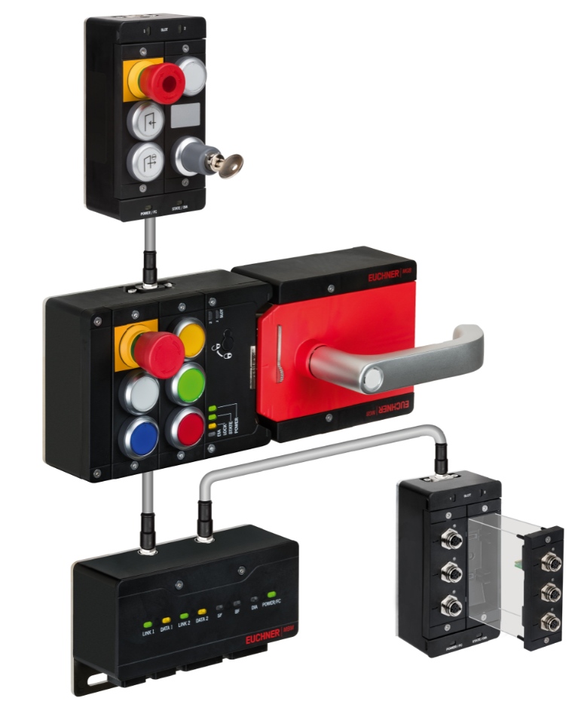

02 EUCHNER Bus System MBM
