PRESS RELEASE
Leinfelden, January 2023

Euchner: New lighting design for logistics building saves energy and CO₂

Energy consumption nearly halved

Safety engineering specialist Euchner has modernized the lighting system for its two-storey logistics building in Leinfelden near Stuttgart. This enabled the company to cut energy consumption by nearly half and save 10.2 metric tons of CO₂.
Euchner’s corporate philosophy covers everything from protecting the environment and handling natural resources with consideration to reducing energy consumption and using low-pollutant materials. The company continuously puts these values into practice at its production locations. This is why one of the logistics buildings recently received a new lighting system: Euchner replaced the old fluorescent tubes with modern LEDs and installed an optimized lighting control system. “This step will reduce the building’s annual energy consumption by around 27,700 kilowatt-hours and save around 10.2 tons of CO₂ emissions per year,” says a pleased Lorenz Fohmann, who is responsible for building services and energy management at Euchner. “This corresponds to a CO₂ equivalent of 20 round-trip flights between Frankfurt am Main and Mallorca or driving a car around the globe 1.3 times.”
Better lighting plus optimized energy efficiency
With a floor space of almost 3,000 square meters, the two-storey logistics building in Leinfelden was a good candidate for savings. The building houses an automated small-parts store with a capacity of 14,000 storage containers for safety switches and other products awaiting shipment around the world. The company operates in two shifts, and the small windows admit only little daylight into the rooms. This meant artificial lighting was needed for many hours per day. “We first calculated how much light was actually required and then optimized the lighting for the individual areas,” explains Fohmann. The result was astounding: “We were able to improve the lighting despite halving the number of lamps, and could reduce our energy consumption by around 43 percent,” says Fohmann. “The new lights are also much more efficient, which is shown by the area-specific lighting power. Here our superb characteristic value of 4.4 watts per square meter is significantly less than the average of 9 watts per square meter for a comparable building.”
Acting responsibly and sustainably is at the heart of everything Euchner does. “We are always working on ways to minimize our energy consumption and enhance our company’s energy efficiency,” stresses managing director Stefan Euchner. “We’ve recently implemented numerous projects to protect the environment and save energy at our locations. Converting the lighting system in the logistic building is another important step on this path.“
[Characters with blanks 2,879]
EUCHNER – More than safety.

Picture: Euchner GmbH + Co. KG

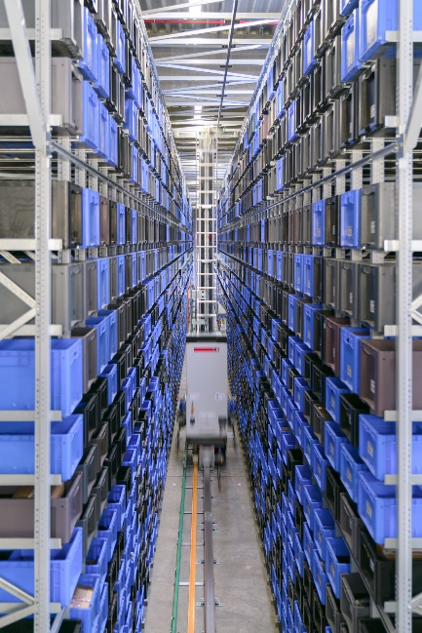
Euchner halves its energy consumption and saves 10.2 metric tons of CO₂ with a new lighting design in the logistics building.

Über EUCHNER GmbH + Co. KG
EUCHNER GmbH + Co. KG in Leinfelden is an international family-owned company with more than 900 employees worldwide. 20 subsidiaries cover the globe along with 22 sales offices. The company is managed by Stefan Euchner. Switchgear has been developed at EUCHNER for 70 years. These devices are used primarily in the field of mechanical engineering. The company has a leading position in safety engineering. EUCHNER safety switches monitor the position of safety guards on machines and installations electromechanically and electronically with a high degree of reliability.

More information about the company is available on the Internet at www.euchner.com

EUCHNER GmbH + Co. KG
Kohlhammerstraße 16
70771 Leinfelden-Echterdingen
Deutschland
Tel. +49 711 7597- 0
Fax +49 711 753316
www.euchner.de
info@euchner.de

Pressekontakt
Ariane Walther
Marketing / Corporate Communications
Tel. +49 711 7597- 163
Fax +49 711 7597- 385
press@euchner.de

Social Media

