PRESS RELEASE
Leinfelden, April 2021

EUCHNER Comes Out Top!
EUCHNER has been awarded Product of the Year 2021 in the safety category by Computer & AUTOMATION for its intelligent combination of two products.
Last year, the magazine Computer & AUTOMATION nominated 96 exceptional products and systems from over 500 entries across 12 categories. It was then its readers’ turn to choose their favorite, with nearly 50,000 of them casting their vote for Product of the Year 2021.
EUCHNER was awarded the bronze trophy in the safety category for its CES-C07 safety switch and ESM-CB safety module. The safety switch supplies process-related parameters in real time, which can be used to gather information for preventive maintenance, for example. The sensors measure relevant parameters in the surroundings such as temperature and voltage, enabling the installation to be analyzed while it is running.
Tampering attempts can be detected by plausibility checks. When the safety module is used in combination, this information is automatically polled from each switch in the chain and provided to the control system via IO-Link. “Together, the two products can communicate at Industry 4.0 level,” says Dr. Hannes Zipse, EUCHNER’s Sales Manager for Germany.
This successful duo, which opens up new possibilities for all types of installations, was a real winner with the readers of Computer & AUTOMATION.
((1.359 characters))
EUCHNER – More than safety.

EUCHNER GmbH + Co. KG
EUCHNER GmbH + Co. KG in Leinfelden is an international family-owned company with more than 800 employees worldwide. 18 subsidiaries, of which ten are in Europe, four in Asia and four in North and South America, cover the globe along with 22 sales offices. The company is managed by Stefan Euchner. Switchgear has been developed at EUCHNER for more than 60 years. These devices are used primarily in the field of mechanical engineering. The company has a leading position in safety engineering. EUCHNER safety switches monitor the position of safety guards on machines and installations electromechanically and electronically with a high degree of reliability.

More information about the company is available on the Internet at www.euchner.com

EUCHNER GmbH + Co. KG
Kohlhammerstraße 16
70771 Leinfelden-Echterdingen
Germany
Tel. +49 711 7597- 0
Fax +49 711 753316
www.euchner.de
info@euchner.de

Press contact
Alexandra Weiße
Marketing / Corporate Communications
Tel. +49 711 7597- 278
Fax +49 711 7597- 385
press@euchner.de

Social Media

Images: EUCHNER GmbH + Co. KG

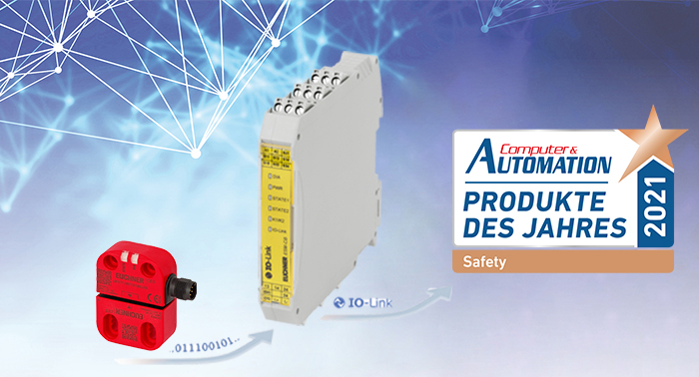
01-Euchner-product-of-the-year.jpg

