Leinfelden, April 2022

Highly multifunctional and now available with EtherCAT P/FSoE too

EUCHNER has upgraded its MGB2 products with EtherCAT. The products’ integration into the safe EtherCAT P/FSoE is particularly noteworthy, because the MGB2 Modular is the world’s first guard locking device for the safe EtherCAT. As in years prior, the safety engineering supplier is once again playing a pioneering role.
2009 saw EUCHNER developing the first safety door system incorporating PROFINET/PROFIsafe and thereby establishing an entirely new category of safety door systems with an integrated, safe bus connection, for example. Again in 2014, EUCHNER was the first company to market a safety door system using integrated EtherNet/IP with CIP Safety.
Based in Leinfelden near Stuttgart, this long-standing company has always remained true to the basic MGB2 principle of modularity and simple integration. Users can customize guard protection with all MGB2 systems.
The MGB2 system protects safety doors and fences in machines and installations against dangerous machine movements and combines a safety switch, bolt and door locking mechanism into a single unit. The modular design and the optional MSM submodules offer countless variants, additional functions, different networking options and intelligent communication features for Industry 4.0 applications.
Ever since it entered the market four years ago, the MGB2 Modular for PROFINET/PROFIsafe connection has therefore been in high demand. Likewise, the safety door systems for EtherCAT/FSoE connection introduced in November 2021 are now convincing an ever growing number of users.
The MGB2 already has an established reputation in many sectors, particularly in the automotive industry and numerous fields where automation is used. Users benefit from a highly functional door locking system with guard locking that not only meets the highest safety level up to PL e but also has the flexibility to adapt to future requirements. This makes it a very smart investment.

Maximum personalization for safety door systems
No two safety applications are the same. Some production processes need an additional safety device such as an emergency stop to secure safety doors with guard locking, while others need request and acknowledgment buttons to be mounted directly onto the safety door. It’s also possible that, over time, new requirements may arise for safety door systems as a result of conversions or expansions to machines, installations and production lines. A solution that can be tailored to meet all of these requirements is a sensible choice. The MGB2 Modular from EUCHNER can meet individual requirements thanks to its modular system design.

Modularity through clear division of tasks
The MGB2 Modular is designed for maximum versatility. This is achieved by spreading the individual functions across different modules.
The three main functions, bus communication, door monitoring and control and indication, are implemented in separate modules and submodules. The MBM bus module acts as the system's “head.” All information from the connected modules comes together here and moves along to the control system over the designated bus system. The control system, in turn, sends its signals via the bus module to the connected system modules to control guard locking or activate a lamp, for example.
MGB2 interlocking and locking modules monitor the door position and lock the guards. These modules feature two special slots to accommodate submodules.
MSM submodules feature a wide range of controls and indicators such as pushbuttons, selector switches, key-operated rotary switches and emergency stop buttons.
If even more functions are needed, adding an MCM expansion module to the system can provide capacity for up to four extra submodules. This makes the MGB2 system a small, decentralized control center on the safety door.

[Information box: system overview]

- MBM bus modules |  | 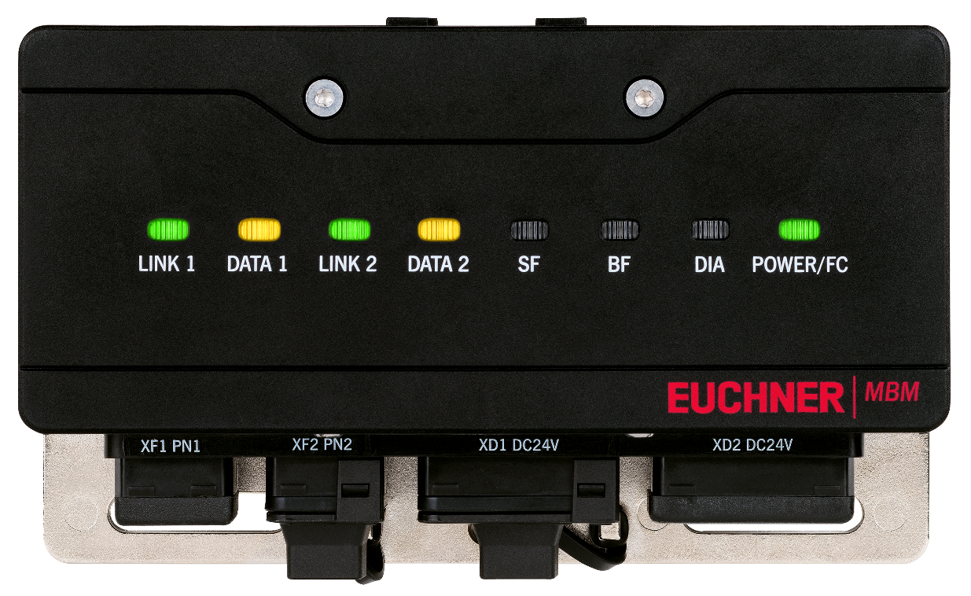
 | - Gateway between all MGB2 locking modules, MCM expansion modules, MSM submodules and the PLC via various industrial networks
- MGB2 Modular locking modules with handle module |  | 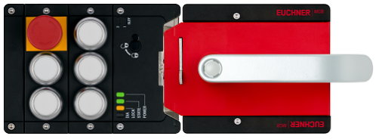
- Modular door locking systems
- For doors hinged on the right or left
- For hinged or sliding doors
- Space for two MSM submodules
- MCM Modular expansion modules |  | 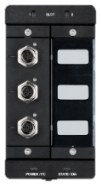  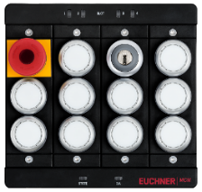
- Space for two or four MSM submodules
- Direct control of a stack light

- MSM submodules |  | 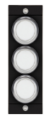  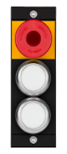  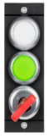  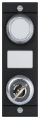  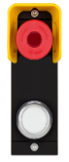  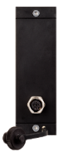
- Modules with up to three controls and indicators
- Enabling switches, safe acknowledgment buttons, emergency stop switches and many other functions can be connected

Six at once –
up to six safety doors on one bus module

Separating the locking module from the bus module offers two important advantages. For one thing, up to six MGB2 Modular units can be connected to a single bus module. Consider this commonly encountered practical example: collecting the signals from two or three safety doors previously required two or three bus nodes – but just one is needed with the MGB2 Modular. Besides needing fewer devices, the user also requires fewer network cables and addresses, and ultimately also saves on storage capacity in the control system, which is becoming all the more expensive, not least in view of the smart factory of tomorrow.

For another thing, all modules can be mounted remotely. Particularly where space is tight, this remote mounting allows users to place the system in the most suitable location.
The MGB2 Modular door locking system thus maximizes flexibility.

[Characters with blanks 7,724 (including information box)]
EUCHNER – More than safety.

Pictures: EUCHNER GmbH + Co. KG

01_ MGB2-Modular-aufbau-bsp.png

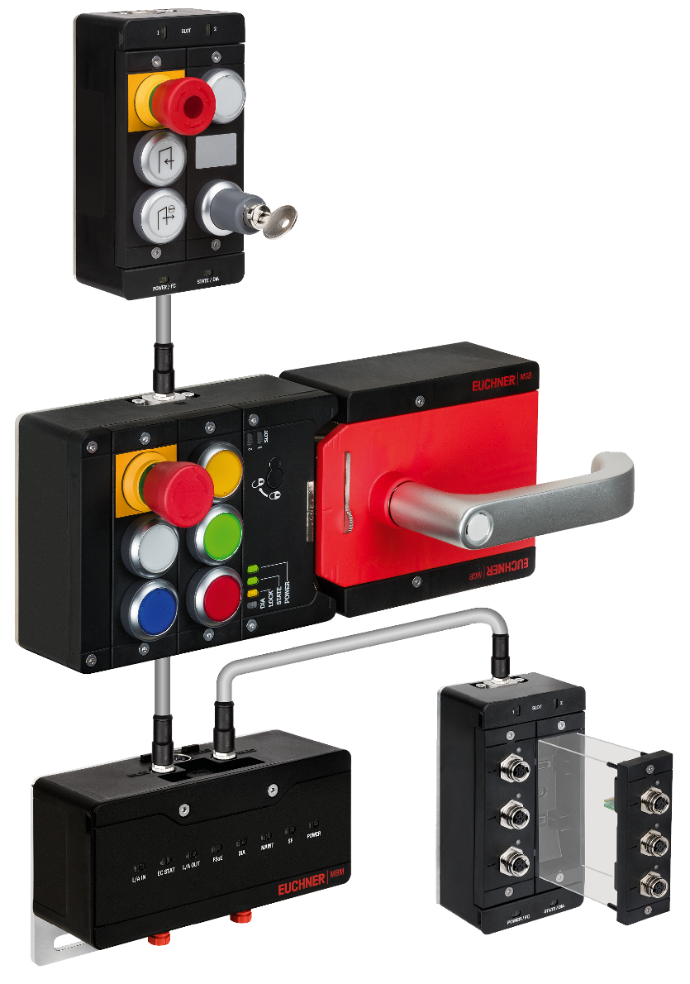
MGB2 Modular from EUCHNER: bus module and expansion module can be mounted remotely.

02_EUCHNER_MGB2_Modular_Wechsel-Submodule.jpg
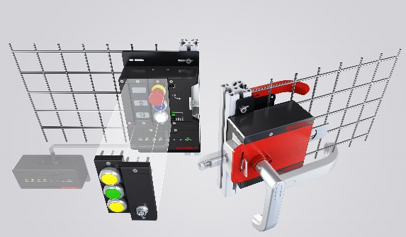

03_MBM_EtherCAT
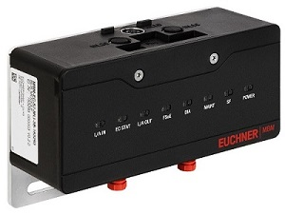

04_MCM_Busmodul_EtherCAT
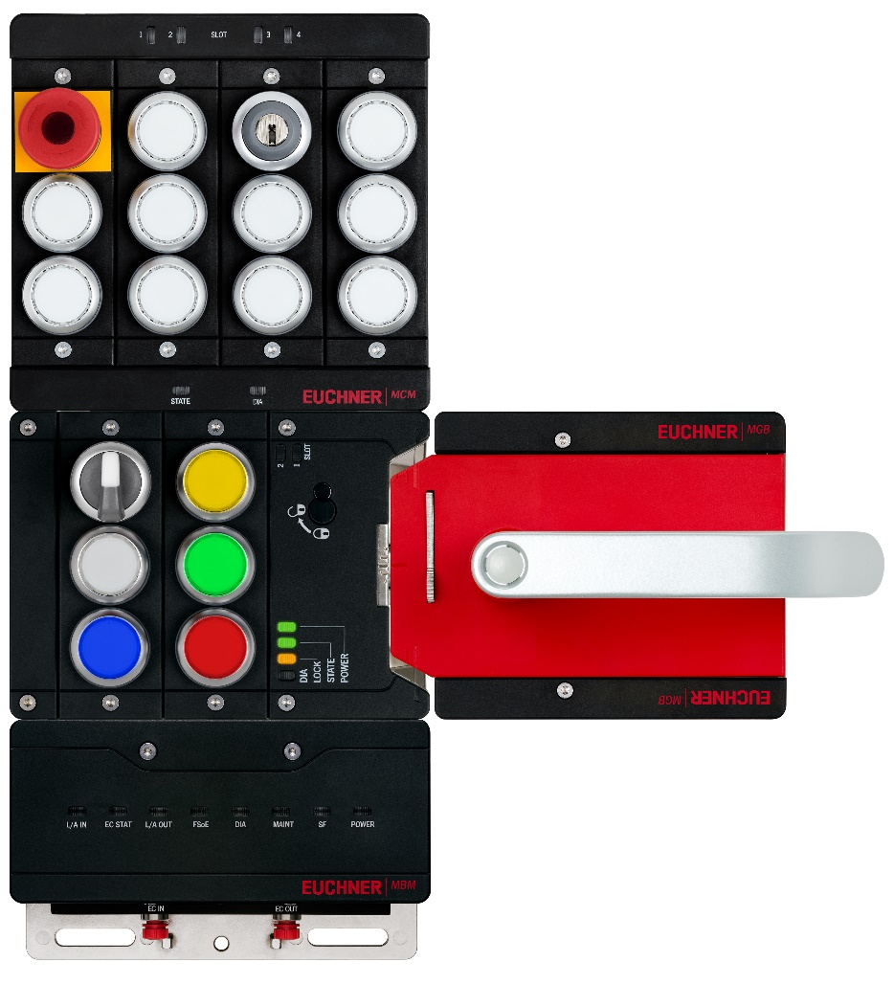
Über EUCHNER GmbH + Co. KG
Die EUCHNER GmbH + Co. KG in Leinfelden ist ein international tätiges Familienunternehmen mit weltweit über 900 Mitarbeitern. 19 Tochtergesellschaften, darunter zehn in Europa, vier in Asien und vier in Nord- und Südamerika, verteilen sich mit 22 Vertriebsbüros rund um den Erdball. Geschäftsführender Gesellschafter des schwäbischen Unternehmens ist Stefan EUCHNER. Seit mehr als 60 Jahren werden bei EUCHNER Schaltgeräte entwickelt. Diese finden ihren Einsatz hauptsächlich im Maschinenbau. Eine Spitzenstellung nimmt das Unternehmen im Bereich der Sicherheitstechnik ein. EUCHNER Sicherheitsschalter überwachen elektromechanisch und elektronisch zuverlässig die Stellung von Schutztüren von Maschinen und Anlagen.

Weitere Informationen rund um das Unternehmen finden Sie im Internet unter www.EUCHNER.de

EUCHNER GmbH + Co. KG
Kohlhammerstraße 16
70771 Leinfelden-Echterdingen
Deutschland
Tel. +49 711 7597- 0
Fax +49 711 753316
www.EUCHNER.de
info@EUCHNER.de

Pressekontakt
Ariane Walther
Marketing / Corporate Communications
Tel. +49 711 7597- 163
Fax +49 711 7597- 385
press@EUCHNER.de

Social Media

