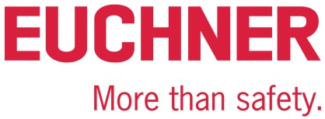

PRESS RELEASE
Leinfelden, November 2019

Euchner enhances its Safety Services

Comprehensive services for machinery safety

Euchner is expanding its machinery safety services to meet the ever-increasing demand from machine manufacturers and operators for consulting requirements. Euchner Safety Services offers professional services throughout the entire life cycle of machines and installations. The expansion of its engineering services allows the experienced team to support its customers as a complete service provider: Alongside design and planning, these services also encompass the implementation and integration of safety solutions. Machine operators in particular will benefit from this comprehensive service for their modifications, integration and retrofitting.
There is a growing demand for support in machinery safety because the legislation in this field is constantly changing. At the same time, the machines and installations themselves are becoming ever more complex. However, safe machinery and installations not only protect operating personnel from hazards, but also the processes from interruptions – which ultimately increases the productivity of machines and installations.

Services for machine manufacturers: from design right through to EC conformity
Euchner Safety Services is there to support machine manufacturers from the very beginning. “Proper safety strategies and the use of appropriate safety components are crucial for optimum availability of installations. Machine manufacturers have to take this into account from as early as the design stage,” says Detlef Ullrich, head of Euchner Safety Services. Euchner experts therefore support design engineers in the development stages to help them meet the legal requirements of Machinery Directive 2006/42/EC and offer assistance for every step of the process, from the crucial initial stages through to CE certification, be it individual services or complete services.
As part of a risk assessment, experts assess and evaluate potential hazards and suggest measures to reduce risk. They also develop customized safety strategies and, where needed, provide engineering services to integrate the necessary risk reduction measures. Last but not least, the range of services also covers the inspection process for verification and validation as well as all services associated with CE certification. For only when a machine has successfully completed the conformity assessment process and has received CE certification can it be sold in the European Economic Area.

Services for machine operators: championing optimum operational safety
Operators must ensure occupational and machinery safety as soon as they have purchased work equipment, and must continue to do so throughout the machine’s entire life cycle. Euchner Safety Services is on hand to support its customers throughout this cycle, from start to finish.
Work equipment must be inspected regularly and brought up to date with the latest technology to ensure that production conforms to legislation and is fit for the future. In Germany, machines must conform to the requirements of industrial and occupational health and safety law. Euchner Safety Services carries out hazard assessments in accordance with German industrial health and safety law.
Operators often require additional support when carrying out modification and modernization projects on machines, such as conversions, linking and retrofitting. This is where Euchner’s safety experts come in, offering customers a wide range of consulting and engineering services. These services include assessing machines, designing and planning safety solutions, and providing complete system integration – from design and assembly right through to setup and approval. “Implementing safety strategies in real-life scenarios requires a lot of skill and expertise. We are able to draw on our extensive experience in different areas and our membership of national and international standards committees to provide this crucial expertise,” says Detlef Ullrich.

[Characters with blanks 3,993]
EUCHNER – More than safety.

Images: EUCHNER GmbH + Co. KG

01-Euchner-Safety-Services-de.jpg

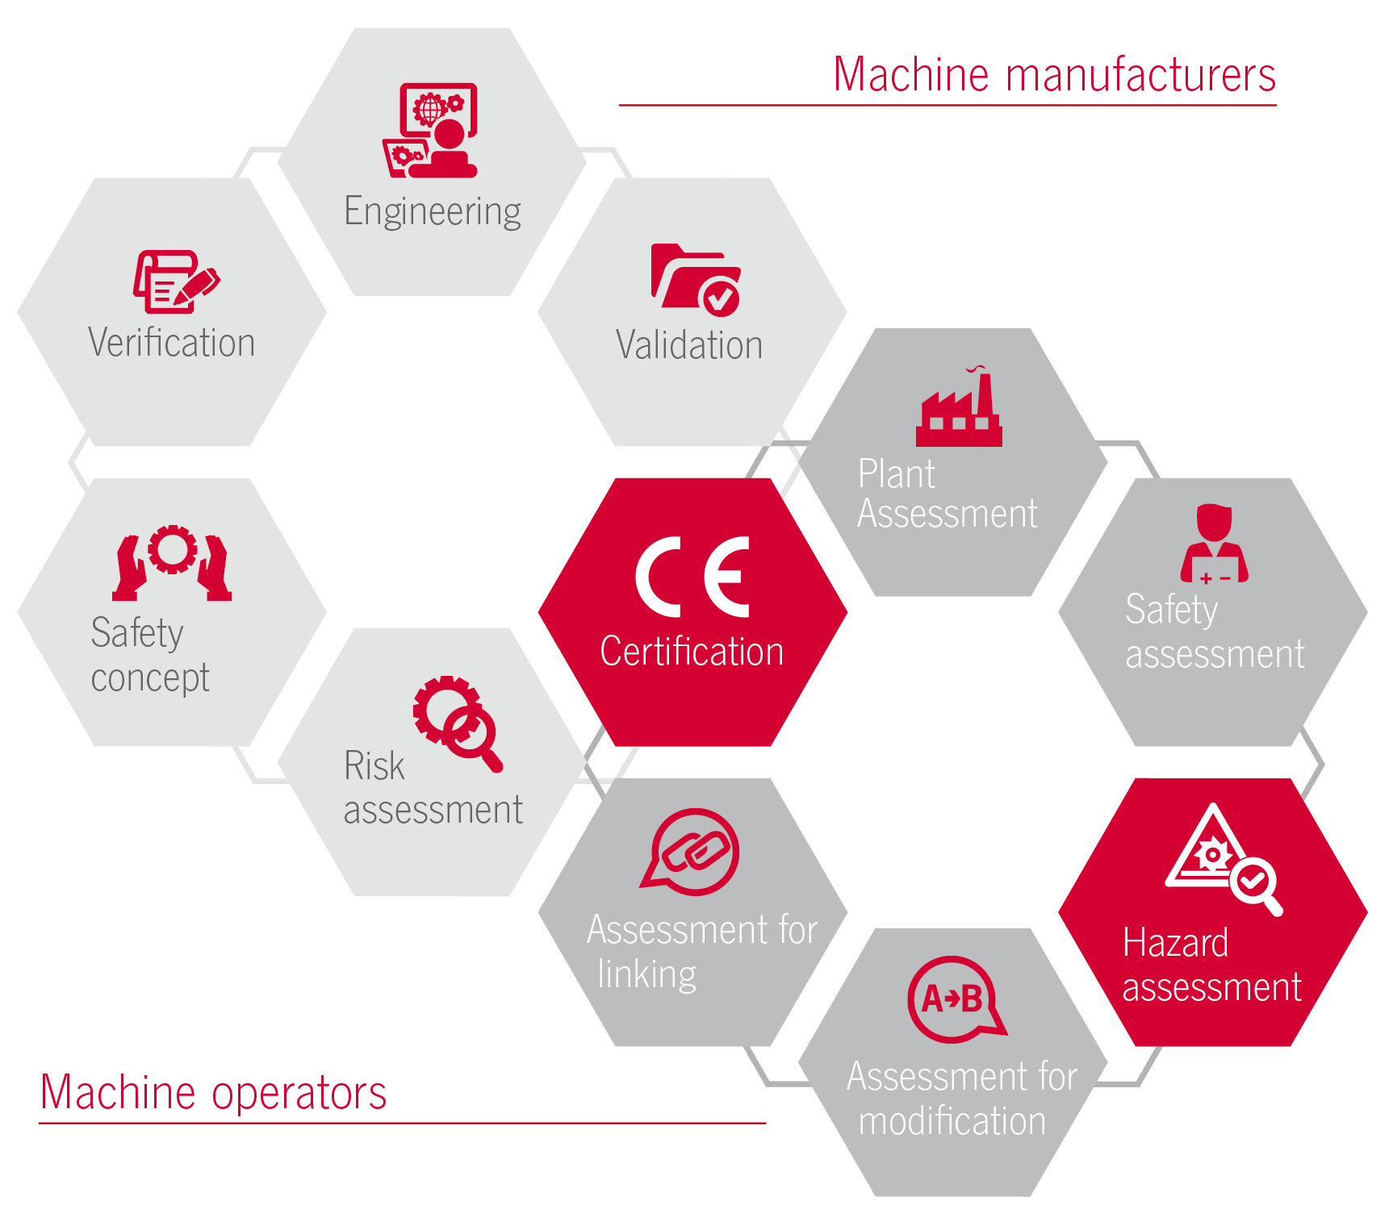

You can rest assured that EUCHNER Safety Services will provide the best professional support throughout all machine and installation life cycles.

Short profile: EUCHNER GmbH + Co. KG
EUCHNER GmbH + Co. KG in Leinfelden is an international family-owned company with more than 800 employees worldwide. 18 subsidiaries, of which ten are in Europe, four in Asia and four in North and South America, cover the globe along with 22 sales offices. The company is managed by Stefan Euchner. Switchgear has been developed at EUCHNER for more than 60 years. These devices are used primarily in the field of mechanical engineering. The company has a leading position in safety engineering. EUCHNER safety switches monitor the position of safety guards on machines and installations electromechanically and electronically with a high degree of reliability.

More information about the company is available on the Internet at www.euchner.com

EUCHNER GmbH + Co. KG
Kohlhammerstraße 16
70771 Leinfelden-Echterdingen
Deutschland
Tel. +49 711 7597- 0
Fax +49 711 753316
www.euchner.de
info@euchner.de

Press contact
Ariane Walther
Marketing / Corporate Communications
Tel. +49 711 7597- 163
Fax +49 711 7597- 385
press@euchner.de

Social Media

