Application Report for Electronic-Key-System EKS
Leinfelden, October 2019

Ritter Sport endorses the Electronic-Key-System EKS
Quality. Safety. Squared.
Chocolate manufacturer Ritter Sport relies on the raw ingredients that are delivered by truck to its warehouse in Waldenbuch, South Germany. But unloading them is a complex operation: a total of 32 key-operated rotary switches would normally be necessary to direct the raw ingredients to the right station. However, thanks to Euchner’s Electronic-Key-System EKS, this number has been reduced to just four read stations, making the process in the new raw ingredients warehouse much more efficient. The food industry is yet another sector where the EKS wins a (chocolate) gold medal.
With a market share of over 20%, Ritter Sport is a square-shaped chocolate delight that is quite literally on the tip of everyone’s tongue. There is no mistaking a bar of Ritter Sport when you see one: the different flavor varieties are as endless as the colors are bold, and the chocolate is square in shape but not in character. Even more important is what is on the inside: every stage of Ritter Sport production is geared towards superior quality and an unrivaled taste. After the cocoa mass, powdered milk and sugar have been mixed together in the kneader, the mixture is then blended and refined before being processed in the conche. A conche is a shell-shaped container where the refined chocolate powder is vigorously ground, blended, aerated and finally liquefied. Depending on the type of chocolate, this refining process can take up to 24 hours. Once the mixture has been tempered and more ingredients have been added, such as nuts or cornflakes, a pouring machine deposits the chocolate into molds to give it that world-famous quadratic shape before it finally passes through the shaking and cooling lines to then be removed from the molds and packaged.
The secret to Ritter Sport’s success is the combination of perfect recipes and high-quality raw ingredients, the most important being the cocoa. As with wine, different geographical locations and processing types create a range of exciting taste varieties. The factory in Waldenbuch uses superior Criollo, Forastero and Trinitario cocoa beans from Nicaragua, Peru, Ghana and the Côte d’Ivoire. And when it comes to the other ingredients, only the best will do.

A quantum leap in efficiency
To ensure that the different ingredients are stored in the right containers when they arrive at the raw ingredients warehouse, a total of 32 key-operated rotary switches would normally be required, bringing with them all the associated disadvantages in the handling process. “Key management starts to become very complex, not to mention the expense of replacing individual lost keys,” explains Sales Engineer Oliver Laier, who is in charge of customer care for Euchner’s famous foodie neighbor.
Euchner’s innovative Electronic-Key-System EKS not only makes this process safer but also much more efficient: all tasks are now carried out by one system with just four read stations, rather than a complex system requiring multiple key-operated rotary switches.
The EKS works using an electronic key and a corresponding key adapter. The electronic key contains a transponder with data memory that allows it to transmit data without using any contacts to the key adapter. In contrast to conventional installations with key-operated rotary switches, it is not necessary to replace the entire system if one key is lost. This isn’t a problem with the EKS, which allows the customer to generate a new electronic key with just a few clicks.
Ritter Sport decided to make the most of these advantages by integrating them in its new raw ingredients warehouse. The process is simple: when the raw ingredients arrive in Waldenbuch by truck, an EKS chip is issued, allowing the employees to unload the delivery at the right receiving station and into the right container.
Each receiving station, path and target container has its own corresponding programmed and numerically marked chip, whose code is read by the RFID readers. The information is then stored on a central database, ready to be processed by the control system. The readers are connected via PROFINET.

The EKS gets Ritter Sport’s seal of approval
Euchner’s Electronic-Key-System EKS is currently responsible for managing Ritter Sport’s entire raw ingredients warehouse and all of the elements and PCs associated with it. “We hope to soon use the system for our production computers as well,” says Peter Schetter, Head of Electrical Engineering at Ritter Sport and responsible for the implementation of the new technology with the help of Control Technician Robin Storino. Storino played a substantial role in the planning and construction of the installation as well as the programming and start of operation.
Ritter Sport is planning to expand its application of the Electronic-Key-System EKS precisely because it has proven so successful in their warehouse. It’s therefore not surprising that Schetter is singing the praises of this innovative solution, giving it the Ritter Sport seal of approval. “The EKS is user-friendly, reliable, forward-thinking, safe, easy to configure and manage, and good value,” he says.
Schetter is even more thrilled by the fact that the EKS’s “birthplace” is only ten minutes down the road from Waldenbuch. “Those Swabian brainiacs at Euchner have delivered once again. It only goes to show that it’s worth shopping locally when it comes to finding pioneering solutions.” But he couldn’t help giving his good neighbors a tongue-in-cheek suggestion for improvement: “It would be even more fitting if the chips came in squares in all our variety colors – then the EKS really would be “Quality.Chocolate.Squared”
[Characters with blanks 6,113]

EUCHNER – More than safety.

Pictures: Euchner GmbH + Co. KG

01-Euchner Ritter Sport Application Report
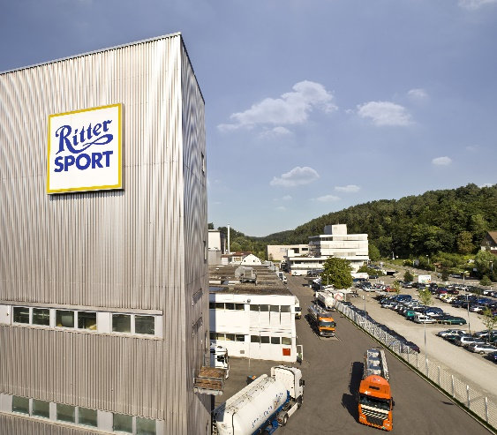
Chocolate manufacturer Ritter Sport in Waldenbuch.

02-Euchner Ritter Sport Application Report
Ritter Sport Alpine Milk Chocolate just before the packing stage.

03.1-Euchner Ritter Sport Application Report
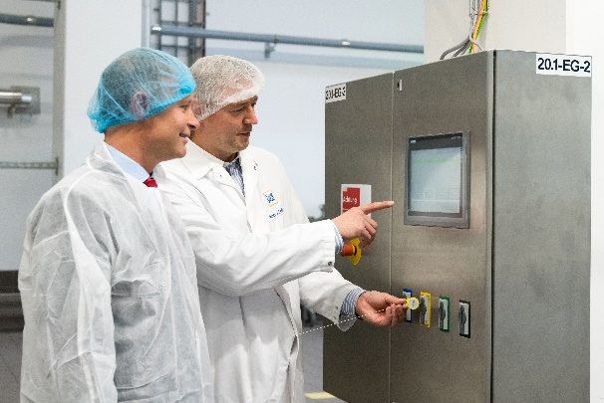
Just one system with four read stations is needed to ensure that the right raw ingredients are filled into the right containers.
03.2-Euchner Ritter Sport Application Report
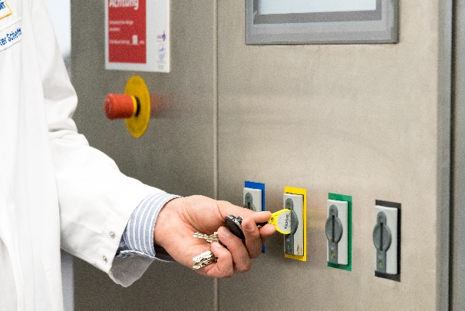
The ingredients are unloaded at the right receiving station and into the right container via a programmed EKS chip.

04.1-Euchner Ritter Sport Application Report and
04.2-Euchner Ritter Sport Application Report
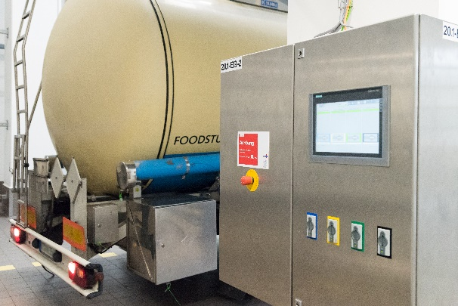
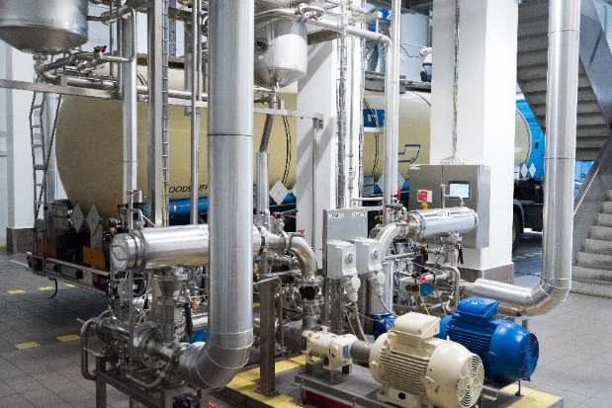
Ritter Sport oversees the unloading of the ingredients using Euchner’s Electronic-Key-System EKS.

05-Euchner Ritter Sport Application Report
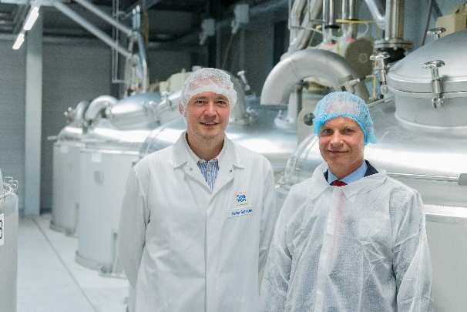
Peter Schetter, Head of Electrical Engineering at Ritter Sport, with Oliver Laier, Euchner’s Sales Engineer.

Short profile: EUCHNER GmbH + Co. KG
EUCHNER GmbH + Co. KG in Leinfelden is an international family-owned company with more than 800 employees worldwide. 18 subsidiaries, of which ten are in Europe, four in Asia and four in North and South America, cover the globe along with 22 sales offices. The company is managed by Stefan Euchner. Switchgear has been developed at EUCHNER for more than 60 years. These devices are used primarily in the field of mechanical engineering. The company has a leading position in safety engineering. EUCHNER safety switches monitor the position of safety guards on machines and installations electromechanically and electronically with a high degree of reliability.

More information about the company is available on the Internet at www.euchner.com

EUCHNER GmbH + Co. KG
Kohlhammerstraße 16
70771 Leinfelden-Echterdingen
Deutschland
Tel. +49 711 7597- 0
Fax +49 711 753316
www.euchner.de
info@euchner.de

Press contact
Ariane Walther
Marketing / Corporate Communications
Tel. +49 711 7597- 163
Fax +49 711 7597- 385
press@euchner.de

Social Media

