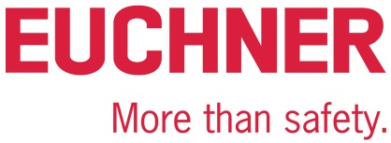

PRESS RELEASE
Leinfelden, August 2023

EUCHNER Safety Services for all your consulting and engineering needs

Legally compliant conversion and retrofitting

Will my machine still be safe after I’ve converted, retrofitted or expanded it? This is the sort of question machine operating organizations in all sectors must face when repurposing or modernizing their installations to meet the latest state of the art. EUCHNER Safety Services is a dependable partner for any project requiring professional support.

Converting and retrofitting instead of buying
Companies are constantly modifying their production machines to adapt them to new products or functions, for example. What’s more, operating organizations retrofit older, technically obsolete machinery to meet the latest state of the art and greatly extend its useful life. A digital retrofit upgrades installations and machinery with modern sensor and communication technology, equipping them to handle the latest demands in the Industry 4.0 environment. Modernizing machines and installations offers the additional benefits of enhancing production efficiency, reducing downtimes, ensuring compliance with the latest legal requirements, and ultimately, extending the machinery’s service life.

Most conversions are not significant modifications, so why not take the plunge?
Machine operating organizations bear a heavy burden of responsibility for protecting their employees. In Germany, this is governed by the Use of Work Equipment Directive 2009/104/EC and by industrial safety regulations. There is often uncertainty about the effects of machinery modification and modernization projects on the legal requirements. Some operating organizations are even so worried about losing the CE conformity and having to repeat the conformity assessment process for their machinery that they avoid making any modifications at all. However, few know that most conversions and modifications are not “significant modifications” requiring CE recertification. As a rule, modifying, converting or expanding a machine always requires an assessment for “significant modification to machines” using the interpretation document from the German Federal Ministry of Labour and Social Affairs (BMAS).
This means that even modifications classified as “not significant” entail obligations for the operating organizations, which must carry out a hazard assessment, determine whether the overall machine corresponds to the state of the art, adapt the documentation in compliance with the Use of Work Equipment Directive, and implement any suitable safety precautions. Construction work could also be required to ensure the machine’s safety.

One-on-one consulting and engineering by EUCHNER Safety Services
EUCHNER Safety Services provides machinery manufacturers and operating organizations with custom consulting and engineering services for everything relating to machinery safety. Our experienced team helps companies implement machinery conversions or modernizations while complying with the law. These experts prepare legally compliant documentation and analyze and assess machinery for “significant modifications” or “assemblies of machinery.” They also conceive, plan and integrate safety solutions, including verification and validation.

Special engineering expertise
As a general contractor, EUCHNER Safety Services offers an all-in-one package for machine operating organizations. The team implements any required construction measures and selects and integrates the best components for the task at hand, no matter the manufacturer. EUCHNER Safety Services’ strength is its wide-ranging engineering expertise. The team comprises design engineers, fitters, installers, and programmers who can cover all disciplines from fluidics to mechanical and electrical engineering, including hardware, safety and standard software. EUCHNER Safety Services also builds control cabinets in house.

[Characters with blanks 4,240]

EUCHNER – More than safety.

Pictures: Euchner GmbH + Co. KG

Figure 01- Detlef-Ullrich
“Around 95 percent of all conversions and modifications to machinery aren’t ‘significant modifications’,” estimates Detlef Ullrich, head of EUCHNER Safety Services.

Figure 02 – EUCHNER Safety Services – engineering
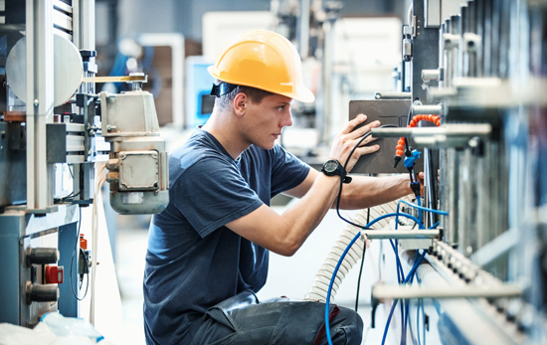
EUCHNER Safety Services’ specialty is its broad engineering spectrum.

Figure 03 – EUCHNER Safety Services – conversion
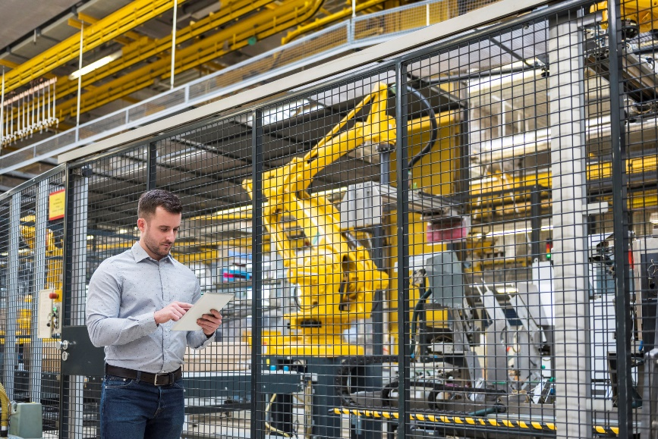
Machines and installations are modernized, converted or expanded over the course of their service life. This generally has direct effects on the machine’s safety requirements as well.

Figure 04 – EUCHNER Safety Services – services for machine operating organizations
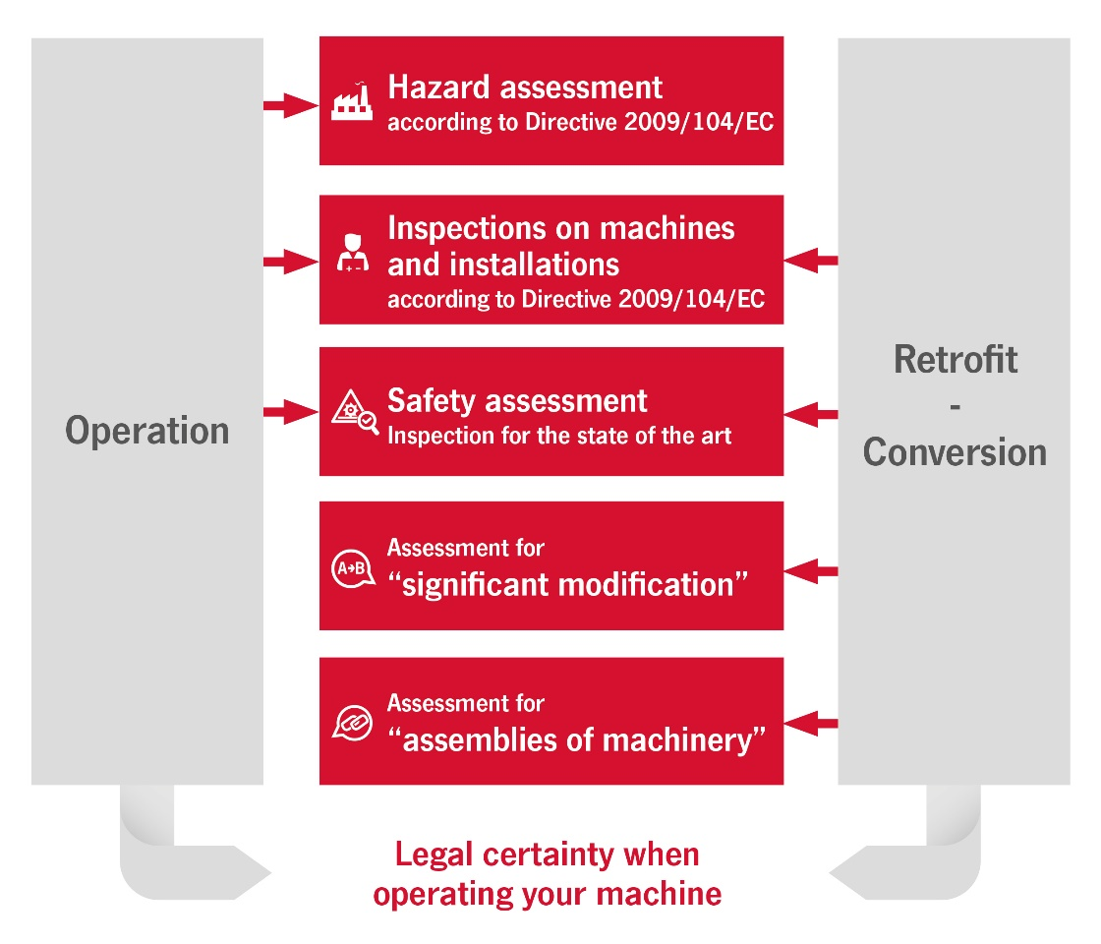

Machine operating organizations are obligated to comply with the latest machinery safety requirements under law. This obligation begins as soon as a machine is purchased, and continues throughout its life cycle. Safety experts from EUCHNER Safety Services accompany machinery operating organizations every step of the way.
Figure 05 – EUCHNER Safety Services – services
EUCHNER Safety Services helps manufacturers and operating organizations meet legal safety requirements throughout all machine and installation life cycles.

The pictures are available at the following download link:
https://my.hidrive.com/share/be8ump8ume

Short profile: EUCHNER GmbH + Co. KG
EUCHNER GmbH + Co. KG in Leinfelden is an international family-owned company with more than 900 employees worldwide. 20 subsidiaries cover the globe along with 22 sales offices. The company is managed by Stefan Euchner. Switchgear has been developed at EUCHNER for 70 years. These devices are used primarily in the field of mechanical engineering. The company has a leading position in safety engineering. EUCHNER safety switches monitor the position of safety guards on machines and installations electromechanically and electronically with a high degree of reliability.

More information about the company is available on the Internet at www.euchner.com

EUCHNER GmbH + Co. KG
Kohlhammerstraße 16
70771 Leinfelden-Echterdingen
Germany
Tel. +49 711 7597- 0
Fax +49 711 753316
www.euchner.com
info@euchner.de

Press contact
press@euchner.de

Social Media

