PRESS RELEASE
Leinfelden, August 2023
Euchner at the 2023 EMO trade show: Hall 9, Stand D24
Innovative safety engineering for metal machining
The metal processing industry has relied on industrial safety engineering from Euchner for decades. Highlights at this year’s EMO include the latest communicating safety guard locking devices, the new CTS compact guard locking device, and the CTA safety switch for harsh environments. Euchner will also be showcasing its versatile new CKS2 key system for machines and installations. The proven MGB2 Modular for safety doors is now available for EtherCAT/FSoE as well.

Innovative guard locking with the compact CTS and the CTA for harsh environments
Safety switches with guard locking are the key to keeping production personnel safe from harm and safeguarding processes. These transponder-coded safety switches with guard locking have the highest safety level. The CTS safety switch is the latest development in this field. Measuring only 135 by 31 by 31 mm and featuring a locking force up to 3,900 N, plus diverse mounting options, it is versatile enough for almost any application. The CTS can be mounted in three directions to protect both hinged and sliding doors, and users can add an escape release at any time.
The CTA safety switch has already proven its worth time after time. Its robust metal housing and a locking force of up to 8,000 N predestine it for use on heavy doors. Offering a high IP65/IP67/IP69/IP69K degree of protection, this switch is the perfect choice for almost any industrial use – especially if this involves a harsh, dirty environment.
All guard locking devices can be connected in several different ways. Combining the devices with an Euchner IO-Link Gateway gives them the additional benefit of communicating in Industry 4.0 applications.

One device, many applications: the CKS2 safe key system
The CKS2 from Euchner is a new, safe key system that is simple to integrate into the overall control system and suitable for a wealth of applications. The user decides whether to use the device as a lockout system, authorization system or key transfer system by selecting the appropriate keys and programming the control system accordingly. Euchner calls this versatility “FlexFunction”. Highly coded, transponder-based keys ensure the highest possible safety level. The device can be connected to IO-Link using the Gateways from Euchner. The CKS2 is also available as a submodule for the MGB2 Modular, opening up many new applications for this successful door locking system.

The multi-talented MGB2 Modular can now do even more
The MGB2 Modular secures safety doors and fences on machines and installations during hazardous machine movements. A modular design is the secret behind the system’s adaptability to specific requirements. The MGB2 Modular consists of a locking module, plug-in submodules with control and indicating functions, plus an MBM bus module for connecting to PROFINET/ProfiSAFE and now to EtherCAT/FSoE and EtherCAT P/FSoE as well. Two submodules let you integrate up to six different controls and indicators in the locking module. And if that weren’t enough, the MCM expansion module considerably enhances what the Multifunctional Gate Box MGB2 Modular can do. All information from the connected modules comes together in the MBM bus module and is transferred to the installation’s control system. Comprehensive diagnostic and communication functions in the form of EtherCAT or PROFINET messages and the integrated web server provide a fast, detailed overview of the device status.
[Characters with blanks 3,930]
EUCHNER – More than safety.

Pictures: Euchner GmbH + Co. KG
01-Euchner-CTS
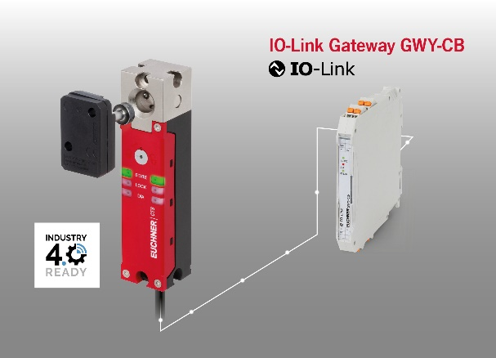
High locking force, a compact design and maximum flexibility are the hallmarks of the new CTS guard locking device.

02-Euchner-CTA
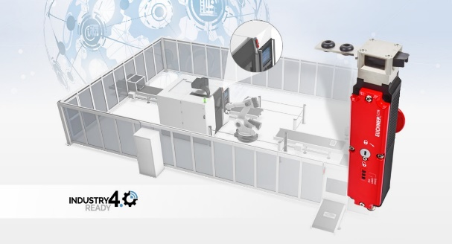
Transponder-coded CTA guard locking device in use in the harshest conditions

03-Euchner-CKS2
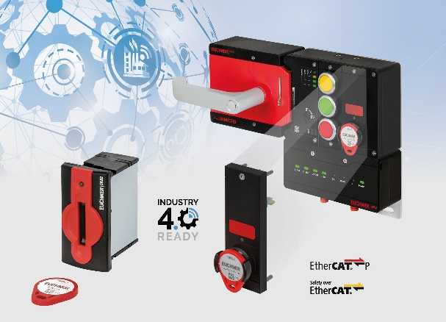
The compact CKS2 key system is available for installation in machines and as a submodule for the MGB2 safety door system.

04-Euchner-MGB2 EtherCAT
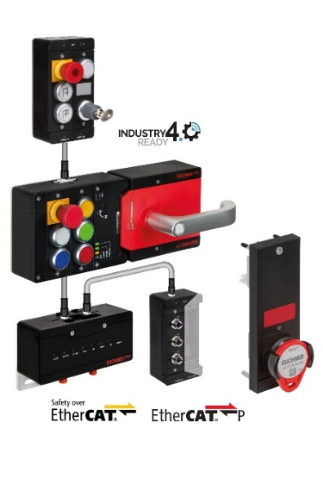
The MGB2 Modular door locking system is now available in a version for connection to EtherCAT P/FSoE and EtherCAT/FSoE in addition to the PROFINET/ProfiSAFE variant.

The pictures are available at the following download link:
https://my.hidrive.com/share/pv6jeeita6

Short profile: EUCHNER GmbH + Co. KG
EUCHNER GmbH + Co. KG in Leinfelden is an international family-owned company with more than 900 employees worldwide. 20 subsidiaries cover the globe along with 22 sales offices. The company is managed by Stefan Euchner. Switchgear has been developed at EUCHNER for 70 years. These devices are used primarily in the field of mechanical engineering. The company has a leading position in safety engineering. EUCHNER safety switches monitor the position of safety guards on machines and installations electromechanically and electronically with a high degree of reliability.

More information about the company is available on the Internet at www.euchner.com

EUCHNER GmbH + Co. KG
Kohlhammerstraße 16
70771 Leinfelden-Echterdingen
Deutschland
Tel. +49 711 7597- 0
Fax +49 711 753316
www.euchner.de
info@euchner.de

Pressekontakt
press@euchner.de

Social Media

