PRESS RELEASE
Leinfelden, December 2019

SPS Trade Fair Review 2019
Euchner stays ahead of the game with its product innovation
This year's SPS, a trade fair for smart automation, was a success story for Euchner. The pioneer in industrial safety engineering impressed visitors with its new products for IoT applications. The compact CTM guard locking device, the MGB2 Modular safety door system and the new RFID switch for the CES-C07 position sensor drew the biggest crowds. There was also a lot of demand for the consulting and engineering services offered by Euchner Safety Services. Euchner has every reason to be extremely satisfied. "This year's trade fair was once again very well attended and we had the pleasure of speaking to old and new customers. We now have many requests for quotation and concrete projects in our order book," said Managing Director Stefan Euchner. Among the visitors were international corporations as well as medium-sized companies from industries including tool and packaging machinery, food, pharmaceuticals, and automotive. Euchner has longstanding partnerships with many different companies.
Dr. Hannes Zipse, Head of Sales, gave this assessment of the trade fair: "SPS was another opportunity for us to demonstrate our expert market knowledge and our commitment to our customers. Our latest product developments mean we are already very well placed to navigate the growing market demands in digitalization." Euchner offers a wide range of safety switches that provide valuable diagnostic data via an IO-Link Gateway, meaning they are suitable for applications such as preventive maintenance.
The latest addition to this group of products is the new CTM compact door locking mechanism for small flaps and lightweight doors. Visitors were impressed not only by its IoT communication feature but most of all by how small it is. At just 120 x 36 x 25 mm, the CTM is one of the smallest guard lockings on the worldwide market. The real bonus is that the switch can be installed discreetly in the housings of machines. The innovative ball actuator supported on an elastomer bearing can secure doors with pivoting radii as small as 150 mm.

No more indefinite downtimes
Another crowd-puller at the trade fair was the new CES-C07 safety switch, which offers new possibilities for the design of safety solutions in combination with the ESM-CB safety module. The working duo's intelligent IoT communication feature provides many benefits in terms of machine availability because the CES-C07 supplies comprehensive diagnostic data. What's more, it supplies process-related parameters in real time, meaning information on preventive maintenance is available right at the point that the customer needs it. The sensors measure relevant parameters in the surroundings to indicate problems before a machine failure can occur. With a suitable plausibility check, this system can even detect attempts at tampering.
Modularity enables customized safety door systems
Another particular highlight of SPS was the very successful Multifunctional Gate Box MGB. This is the latest generation of Euchner's modular safety door system, which allows users to design protection for guards that meets their individual needs. The MGB2 Modular and the MGB2 Classic offer more variations, additional functions, different networking options and intelligent communication features for IoT applications. The MGB2 Modular for PROFINET has enjoyed high demand on the market ever since it was launched a year ago. The conventionally wired MGB2 Classic has been available since summer 2019 and its many advantages make it just as popular with an ever-increasing number of users.
Comprehensive services for machinery safety
With its expanded portfolio of consulting and engineering services for machinery safety, Euchner Safety Services also stood out from the crowd. Its team of experts offers machine manufacturers and operators professional services throughout the entire life cycle of their machines and installations. Having expanded its engineering services, Euchner Safety Services is now a full-service provider, covering not only design and planning but also the implementation and integration of safety solutions. Machine operators in particular will benefit from this comprehensive service for their conversions, integration and retrofitting.

[Characters with blanks 4,595]
EUCHNER – More than safety.

Pictures: Euchner GmbH + Co. KG
Download link for the pictures:
https://www.euchner.de/de-de/ueber-euchner/news/news-details/euchner-punktet-mit-produktinnovationen---6799/

01-Euchner-auf-der-Industriemesse-SPS-2019.jpg
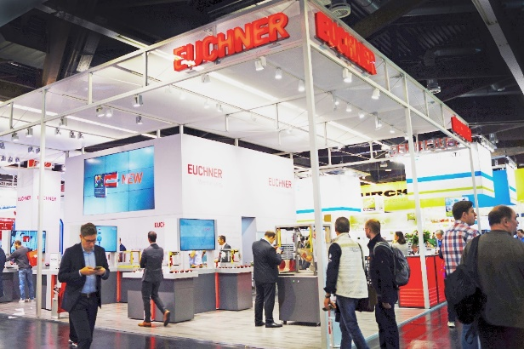
SPS 2019 was a success story for Euchner.

02-Euchner-Sicherheitszuhaltung-CTM.jpg
03-Euchner-Sicherheitszuhaltung-CTM.jpg
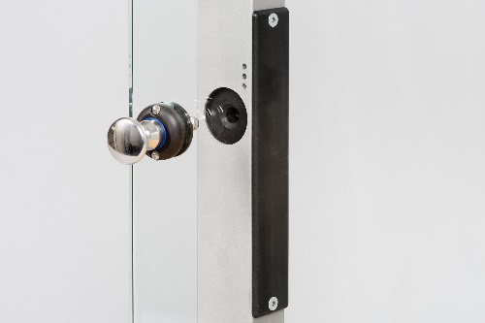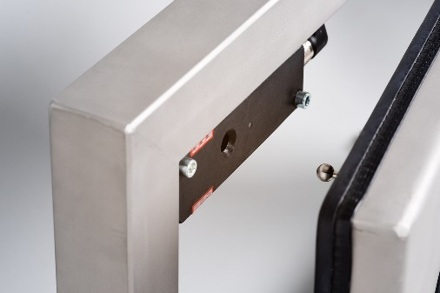
Almost invisible: Euchner's new CTM door locking mechanism can be easily built into the housings of machines.

04-Euchner-Sicherheitszuhaltung-CTM.jpg
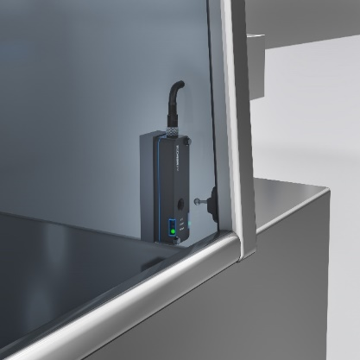
The flexible ball actuator on the CTM series is an ideal solution for even the smallest door radii in machines where installation space is at a premium.

05-Euchner-Sicherheitssensor-CES-C07-Auswertegeraet-ESM-CB-Industrie4.0.jpg

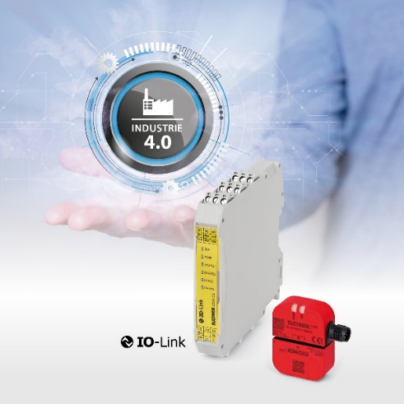
Safety switch CES-C07 and safety module ESM-CB: particularly in smaller installations, these efficient team players can significantly reduce downtimes. All the relevant sensor and device data are sent to the control system via IO-Link.

06-Euchner-Schutztuersystem-Multifunctional-Gate-Box-2-Modular.jpg
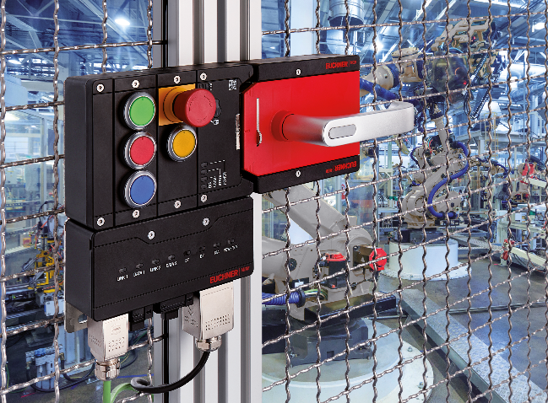
Euchner's MGB2 generation is a modular and highly flexible system fit for the future; submodules can be equipped with customized functions. Subject to modifications or addition of supplementary functions.

Short profile: EUCHNER GmbH + Co. KG
EUCHNER GmbH + Co. KG in Leinfelden is an international family-owned company with more than 800 employees worldwide. 18 subsidiaries, of which ten are in Europe, four in Asia and four in North and South America, cover the globe along with 22 sales offices. The company is managed by Stefan Euchner. Switchgear has been developed at EUCHNER for more than 60 years. These devices are used primarily in the field of mechanical engineering. The company has a leading position in safety engineering. EUCHNER safety switches monitor the position of safety guards on machines and installations electromechanically and electronically with a high degree of reliability.

More information about the company is available on the Internet at www.euchner.com

EUCHNER GmbH + Co. KG
Kohlhammerstraße 16
70771 Leinfelden-Echterdingen
Deutschland
Tel. +49 711 7597- 0
Fax +49 711 753316
www.euchner.de
info@euchner.de

Press contact
Ariane Walther
Marketing / Corporate Communications
Tel. +49 711 7597- 163
Fax +49 711 7597- 385
press@euchner.de

Social Media

