PRESS RELEASE
Leinfelden, March 2020

Euchner presents new extension and locking module

New addition to the MGB2 family for even greater functionality

Euchner has unveiled two new modules for its successful MGB2 Multifunctional Gate Box Modular. The new, small version of the MCM extension module offers space for up to six functions, which can be designed to meet individual requirements. What’s more, the new MSM submodule provides users with additional safety inputs for connecting external switches, meaning they can easily be connected to PROFINET / PROFISAFE.
MCM: compact, scalable and powerful
Euchner now has the perfect solution for users who require more than the six functions available with the MGB2 Modular safety door system. The new compact MCM extension module has two slots, meaning it can be assembled with up to six control or application elements, for instance with an emergency stop button and enabling switch or with a key-operated rotary switch. This means users can choose between this small extension module and the existing larger version, which has four slots to accommodate up to twelve additional control and application elements. The MCM has many standout benefits. For example, the submodules with the function elements are simply inserted into the extension modules via a hot-plug and need only minimal configuration before they are ready for operation. The submodules can also be easily replaced if necessary. There are no limits to the MCM’s functional possibilities and applications. It can be installed separately from the MGB locking module and bus module – inside a production area, for example, with the bus module installed outside. The MCM can also be used in combination with the bus module without a locking module or door handle.

MSM submodule: decentralized peripheral as Plug and Play
The MCM extension modules can be used with the new MSM submodule as a decentralized peripheral for connecting electromechanical safety switches with M12 plugs. The fail-safe inputs can record the signal states of safety switches such as rope pull switches, emergency stop buttons and position switches and can transfer the safety signals to the control system via PROFINET using the PROFISAFE protocol. The MSM submodule has three dual-channel digital inputs, allowing up to six slots to be used as secure inputs when using the small MCM extension module. The MSM is equally suitable for M12 push-pull plugs and M12 threaded plugs. In addition, the system is hot-pluggable during operation and needs only minimal configuration before it is ready for use.
The MGB2 Modular has a modular system design to give users greater flexibility. As a result, extension modules and submodules are easily scalable and functions can be expanded and changed without difficulty. This means users benefit from a system that is customizable and flexible enough to meet any potential future requirements.

[Characters with blanks 3,198]

EUCHNER – More than safety.

Pictures: Euchner GmbH + Co. KG

01-Euchner-MCM
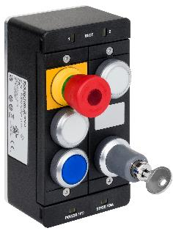
MCM image
The new compact MCM extension module has two slots and can be assembled with up to six control or application elements, for instance with an emergency stop button, enabling switch or key-operated rotary switch.

02-Euchner-MSM
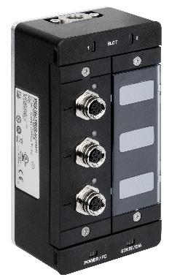

The new MSM submodule can be used as a decentralized peripheral for connecting electromechanical safety switches with M12 plugs.
Short profile: EUCHNER GmbH + Co. KG
EUCHNER GmbH + Co. KG in Leinfelden is an international family-owned company with more than 800 employees worldwide. 18 subsidiaries, of which ten are in Europe, four in Asia and four in North and South America, cover the globe along with 22 sales offices. The company is managed by Stefan Euchner. Switchgear has been developed at EUCHNER for more than 60 years. These devices are used primarily in the field of mechanical engineering. The company has a leading position in safety engineering. EUCHNER safety switches monitor the position of safety guards on machines and installations electromechanically and electronically with a high degree of reliability.

More information about the company is available on the Internet at www.euchner.com

EUCHNER GmbH + Co. KG
Kohlhammerstraße 16
70771 Leinfelden-Echterdingen
Germany
Tel. +49 711 7597- 0
Fax +49 711 753316
www.euchner.de
info@euchner.de

Press contact
Ariane Walther
Marketing / Corporate Communications
Tel. +49 711 7597- 163
Fax +49 711 7597- 385
press@euchner.de

Social Media

