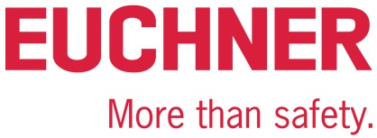

PRESS RELEASE
Leinfelden, May 2022

Euchner at the Hannover Messe 2022 trade show: Hall 9, Stand D16

Introducing the FlexFunction CTS safety switch and the CKS2 key system

Euchner will introduce pioneering safety engineering for Industry 4.0 manufacturing applications at this year’s Hannover Messe. The company will also debut its innovative, one-fits-all FlexFunction products, including the new, compact CTS safety switch and the CKS2 key system. Another spotlight will shine on the successful Multifunctional Gate Box MGB2 Modular with Ethercat P.

One fits all – new FlexFunction CTS safety switch
The new CTS guard locking device features a high locking force, compact design and maximum flexibility, making it the perfect choice for applications requiring a high locking force in a confined space. Measuring only 135 x 31 x 31 millimeters in size, it delivers a maximum locking force of 3,900 N for universal use. The CTS can be mounted in three orientations, permitting flexible use for hinged and sliding doors. What’s more, an escape release can be added at any time. Besides featuring the proven benefits of Euchner’s transponder-coded safety switches with guard locking, the new FlexFunction CTS combines in a single device multiple functions that are otherwise available only in separate variants. With or without guard lock monitoring, actuator code evaluation with high or low coding level – the choice is up to the user with CTS. Functions are selected via the matching actuator. The CTS additionally offers various connection options.

CKS2 – lockout and starting with a single system
The new CKS2 system is perfect when it comes to safe starting or stopping of dangerous machine movements independently of the installed safeguards. In combination with highly coded, transponder-based keys, the key adapter CKS2 forms a safe system that meets the highest safety requirements for machine and installation lockout and starting. When combined with the Euchner IO-Link Gateways, the integral evaluation electronics in the compact CKS2 system provides comprehensive diagnostic and communication functions to users. Proven transponder technology and the use of keys with a high coding level provide maximum safety. Developed as a FlexFunction device, the CKS2 system can operate as a lockout system, trapped key system or authorization system as defined by the key version. The CKS2 is also available as a submodule for the successful MGB2 door locking system. It is perfect for use in fully automated logistics systems or complete turnkey installations.
MGB2 Modular – EtherCAT P with FSoE
All functions familiar from the proven MGB2 Modular are now available for the safe EtherCAT P with FSoE too. The compact MBM bus module is available for connection to EtherCAT and EtherCAT P. This development confirms Euchner’s claim to a pioneering role in the sector of safety engineering for bus systems. The comprehensive diagnostic functions in the form of EtherCAT messages and the integrated web server provide a fast and detailed overview of the device status. Setting the parameters is easy, so even replacing the module for servicing is a simple task taking no more than a few minutes.
New: Euchner Academy by Euchner Safety Services
Visitors to the trade show stand are welcome to inform themselves about the impressive range of Euchner Safety Services. The safety experts provide a full range of assistance throughout a machine’s service life – from attending the acceptance test on a machine from the manufacturer to performing periodic inspections in accordance with occupational health and safety regulations and providing safety engineering services for machine design or conversion. Early this year, Euchner expanded its Safety Services portfolio with a wide range of machinery safety courses in a dedicated Academy. At training events held throughout Germany, specialist instructors present the latest aspects and solutions for the safe operation of machines. Plant operators and manufacturers learn about the relevant statutory requirements.
[Characters with blanks 4,484]

EUCHNER – More than safety.

Pictures: Euchner GmbH + Co. KG
01-Euchner-CTS
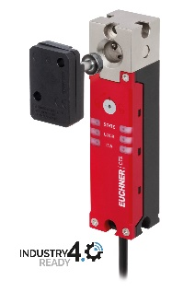
The CTS is ideal for applications requiring a high locking force in a confined space. With the new FlexFunction, the CTS combines in a single device multiple functions that are otherwise available only in separate variants.

02-Euchner-CKS2
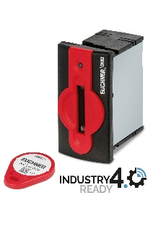
The new CKS2 key adapter meets the most stringent safety requirements for machine and installation lockout and starting.

03-Euchner-MGB-Modular-Ethercat
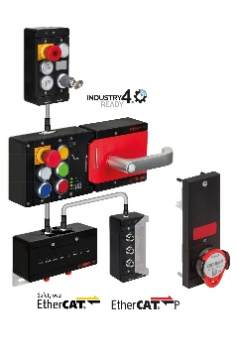
The compact MBM bus module belonging to the successful MGB2 Modular door locking system is now available for connection to EtherCAT and EtherCAT P as well. Users can now integrate a safe key system with the new CKS2 submodule to implement even more applications for the MGB2.

Short profile: EUCHNER GmbH + Co. KG
EUCHNER GmbH + Co. KG in Leinfelden is an international family-owned company with more than 900 employees worldwide. 19 subsidiaries, of which ten are in Europe, four in Asia and four in North and South America, cover the globe along with 22 sales offices. The company is managed by Stefan Euchner. Switchgear has been developed at EUCHNER for more than 60 years. These devices are used primarily in the field of mechanical engineering. The company has a leading position in safety engineering. EUCHNER safety switches monitor the position of safety guards on machines and installations electromechanically and electronically with a high degree of reliability.

More information about the company is available on the Internet at www.euchner.com

EUCHNER GmbH + Co. KG
Kohlhammerstraße 16
70771 Leinfelden-Echterdingen
Germany
Tel. +49 711 7597- 0
Fax +49 711 753316
www.euchner.com
info@euchner.de

Press contact
Ariane Walther
Marketing / Corporate Communications
Tel. +49 711 7597- 163
Fax +49 711 7597- 385
press@euchner.de

Social Media

