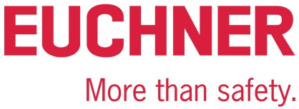

PRESS RELEASE
Leinfelden, March 2024
Euchner at the Hannover Messe 2024: Hall 9, Stand D16

Includes simply everything – the new Electronic-Key-System EKS2

The new Electronic-Key-System EKS2 developed by Euchner in the German town of Leinfelden-Echterdingen is the latest generation of its key systems. The new product has achieved three objectives: it is simple to implement, simple to operate and simple to adjust. For Euchner as a safety specialist, putting the focus on safety engineering comes naturally.

The new generation of products is a logical development of the successful EKS system and has many advantages in terms of digital access control and the selection of a safe operating mode. Template projects with predefined functions and data fields have kept to a minimum the programming work needed to integrate the system. Current requirements, including security factors, for example, have been taken into consideration right from the start.
Euchner uses Profinet for communication purposes, together with reliable, safe semiconductor outputs. The Profinet switch that forms part of the system makes integrating it into an extensive bus system very simple. The 1-of-n safety outputs are directly connected to a safe control system and evaluated there. This allows for the selection of a safe operating mode on the highest safety level, PL e, for example.
Instead of programming the entire selection of safe operating modes in the control system, as was the case in the past, customers can now select a suitable project and simply configure individual parameters via the GSDML file in their configuration software. Other benefits include compact dimensions, industrial keys and a hygienically designed read unit.
“The development process was based on more than 20 years’ experience of the existing EKS system and many discussions with customers,” said product manager Marc Wiederoder and added: “Sometimes only a few improvements are needed to make an already good system even better. Our main objective was to design a system that is as simple as possible for customers to use.”
Euchner is presenting the system for the first time at the Hannover Messe and also giving visitors an initial introduction to other innovations relating to the new Electronic-Key-System EKS2.
[Characters with blanks 2,236]

EUCHNER – More than safety.
Pictures: Euchner GmbH + Co. KG

1 – Overview of the components of the EKS2
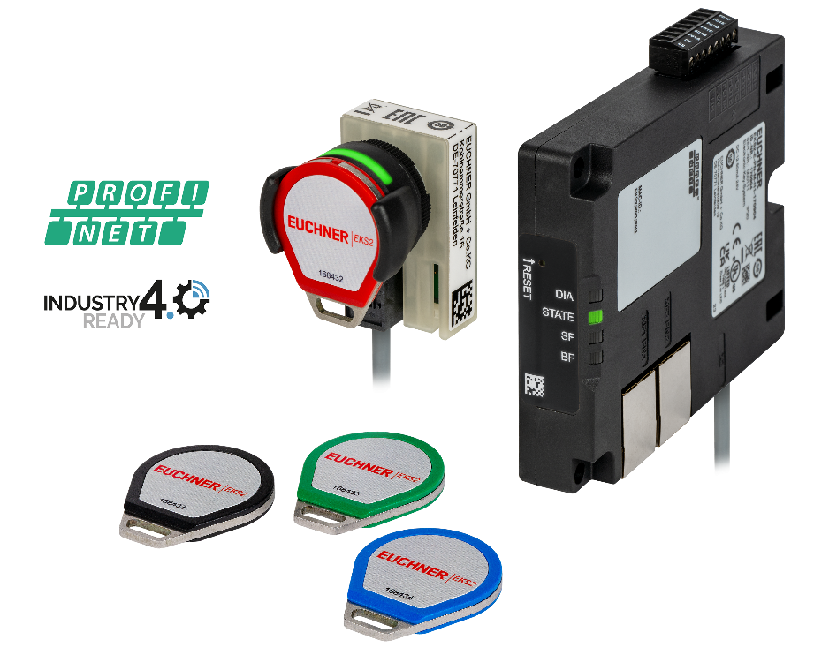
Modular structure with evaluation unit, read unit and keys.

02 – Installation in the panel
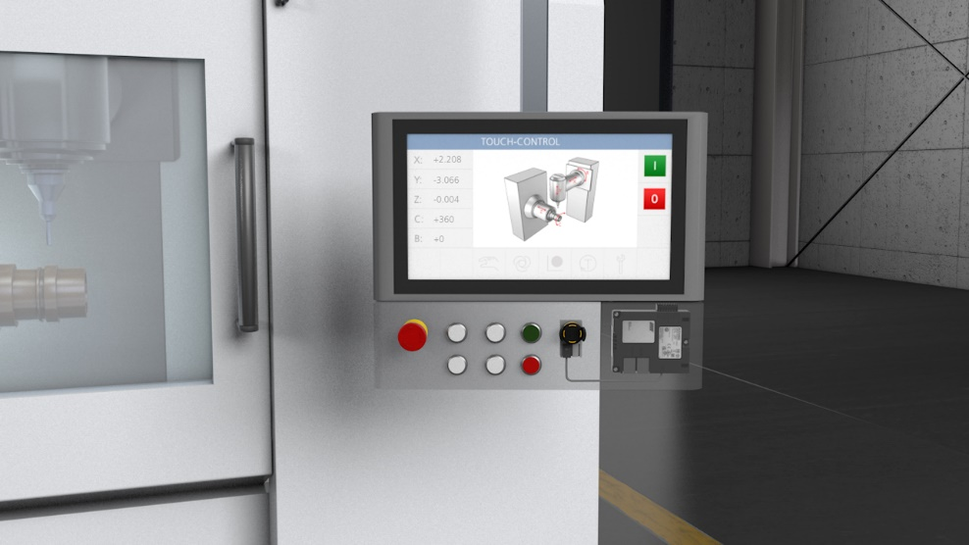
Compact dimensions – it can be installed directly in the panel.

Download the images here: https://my.hidrive.com/share/4ww0eg-fy1
Short profile: EUCHNER GmbH + Co. KG
EUCHNER GmbH + Co. KG in Leinfelden is an international family-owned company with more than 900 employees worldwide. 20 subsidiaries cover the globe along with 22 sales offices. The company is managed by Stefan Euchner. Switchgear has been developed at EUCHNER for 70 years. These devices are used primarily in the field of mechanical engineering. The company has a leading position in safety engineering. EUCHNER safety switches monitor the position of safety guards on machines and installations electromechanically and electronically with a high degree of reliability.

More information about the company is available on the Internet at www.euchner.com

EUCHNER GmbH + Co. KG
Kohlhammerstraße 16
70771 Leinfelden-Echterdingen
Germany
Tel. +49 711 7597- 0
Fax +49 711 753316
www.euchner.com
info@euchner.de

Press contact
press@euchner.de

Social Media

