PRESS RELEASE
Leinfelden, October 2022

Euchner at the SPS trade show: Hall 7, Stand 280

Intelligent safety solutions for automated production

Networked production and control operations call for innovative safety engineering offering communication capabilities and network support. As a pioneer in this sector, Euchner develops future-oriented safety switches and safety systems to meet today’s IoT requirements. With its highly flexible MGB2 Modular door locking system, Euchner provides safety engineering for connecting directly to Ethernet bus protocols such as PROFINET and EtherCAT P. Additionally, the option of communicating via IO-Link is standard on all new Smart Safety solutions. The latest developments include the CKS2 safe key system for installation lockout and starting and the highly compact CTS safety switch featuring an impressive locking force.
In addition to these innovations on exhibit at the trade show, Euchner will showcase its proven safety solutions for the protection of people, machines and products. These solutions have proven their worth for years in sectors as diverse as the automotive, logistics, tool and packaging machine construction, food and pharmaceutical industries. The product range comprises guard locking devices and access management systems as well as products such as door detectors, door locking systems and pendant stations.

One device, many applications: the CKS2 safe key system
Whether for machine and installation lockout and starting, for assigning authorization to select an operating mode, or as a trapped key system – the new CKS2 safe key system is versatile. It is available not only as a compact system with integrated evaluation electronics, but also as a submodule for installation in the MGB2 Modular safety door system. The CKS provides a straightforward solution for many tasks, without all the laborious programming. One key can be assigned to several key adapters in different installations. The CKS2 is also flexibly scalable regarding the number of keys, and the system can therefore replace complicated key exchange boxes and key distribution stations. Thanks to highly coded, transponder-based RFID keys, the system always guarantees maximum protection against tampering and a safety level in accordance with category 4/PL e. The system is easy to integrate into the overall control system. Configuring the key is simply a matter of teaching it in on the key adapter first.
This compact system can be connected to IO-Link via Gateways from Euchner to provide relevant diagnostic and device data to the higher-level control system. This enables users to read the key that was used to operate the installation, for example. As a submodule, the key system is integrated into the MGB2 door protection system and thereby linked directly to the bus module. Together, these two systems are a powerful combination delivering a wealth of new application options.

MGB2 Modular for EtherCAT P/ FSoE
The Multifunctional Gate Box from Euchner now features more networking options and the integrable CKS key system as a submodule. The MGB2 Modular protects machine and installation safety doors and fences during hazardous machine movements. Its modular design is ideal for customization. The MGB2 consists of a guard locking module, the contained submodules for controls and indicators, optional expansion modules and the bus module for connecting to PROFINET/PROFIsafe – and now also to EtherCAT P/ FSoE. The MGB2 Modular is therefore the world’s first guard locking device for the safe EtherCAT. The MBM bus module acts as the system’s “head.” All information from the connected modules comes together here and is transferred to the installation’s control system. Comprehensive diagnostic and communication functions in the form of EtherCAT or PROFINET messages and the integrated web server provide a fast and detailed overview of the device status. The control system, in turn, sends its signals via the bus module to the connected system modules to control guard locking or activate a lamp, for example.

Small size, high locking force, flexible installation
The CTS safety switch offers a high locking force, a compact design and flexible mounting options. Its small size of only 135 x 31 x 31 mm is just as impressive as its high locking force of 3,900 N. Featuring three different mounting directions and a universal actuator on a floating bearing, the CTS can be used in diverse applications ranging from hinged or sliding doors to extremely small door radii. An escape release can be added at any time. The transponder-based safety switch meets the maximum safety requirements for category 4/PL e according to the EN ISO 13849-1 and EN ISO 14119 standards.
Additionally, the CTS is highly flexible. Developed as a FlexFunction switch, the CTS combines in a single device multiple functions that are otherwise available only in separate variants. This means users can choose whether the CTS operates with or without guard lock monitoring and evaluates the actuator code using a high or low coding level. Functions are selected via the matching actuator. In addition to communicating intelligently when connected in series with other Euchner devices, the new switch can also connect to IO-Link.

Euchner is renowned on the market for delivering quality far beyond the requirements codified in standards and laws. Customers can rely on Euchner as a partner with over 60 years of safety engineering expertise. At its headquarters in Leinfelden near Stuttgart, this family-run company develops and manufactures the right solution for any application in any batch size, large or small.

[Characters with blanks 5,941]

EUCHNER – More than safety.

Pictures: Euchner GmbH + Co. KG
01-Euchner-Newcomer-innovative-Sicherheitstechnik
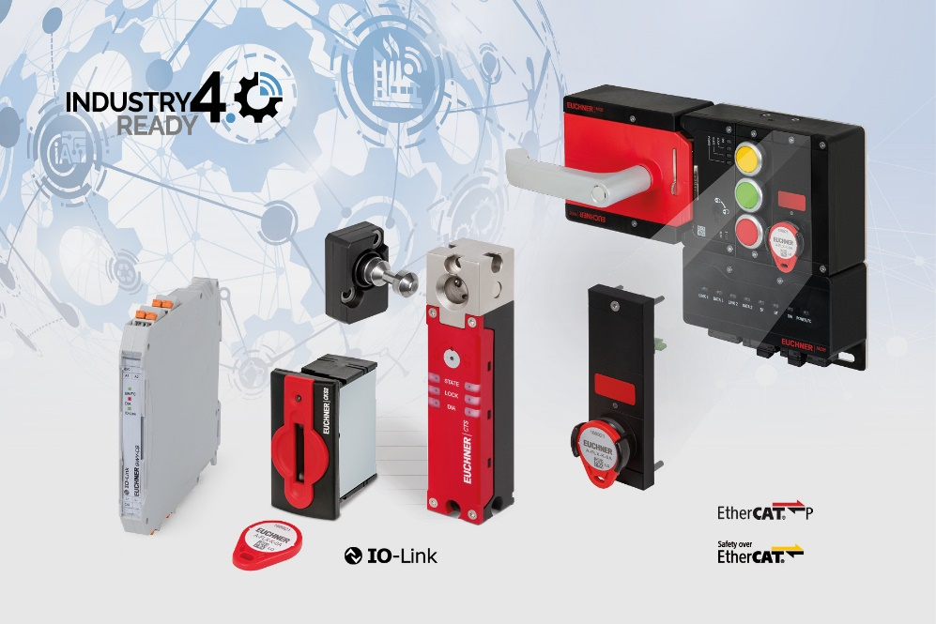
Euchner combines innovative engineering with the latest communication requirements for
automating networked machines and installations.

02-Euchner-CKS2
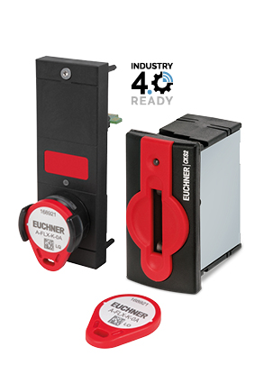
The new CKS2 key adapter meets the highest safety requirements for machine and installation lockout and starting.

03-Euchner-MGB2-Modular+CKS2
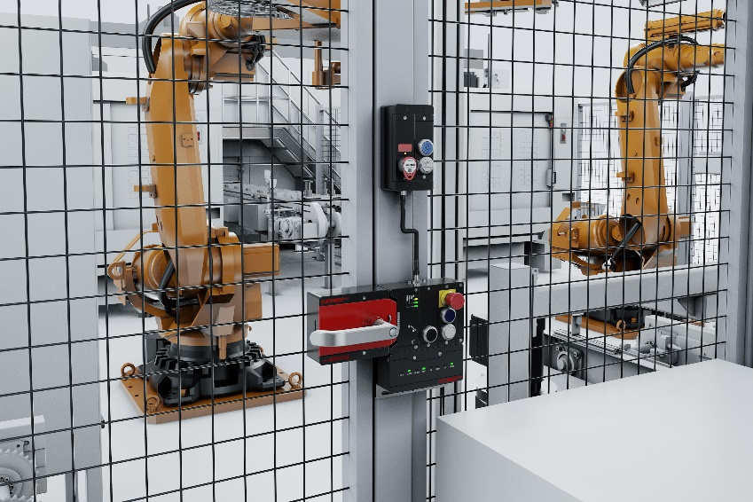
The MGB2 is highly customizable and offers diverse networking options. New features include connection to the EtherCAT P/ FSoE bus protocol and the integrable CKS submodule, a key system for safe installation lockout and starting.

04-Euchner-CTS
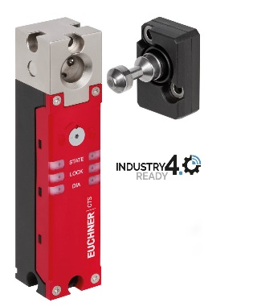
The CTS is ideal for applications requiring a high locking force in a confined space.

Short profile: EUCHNER GmbH + Co. KG
EUCHNER GmbH + Co. KG in Leinfelden is an international family-owned company with more than 900 employees worldwide. 20 subsidiaries, of which ten are in Europe, four in Asia and four in North and South America, cover the globe along with 22 sales offices. The company is managed by Stefan Euchner. Switchgear has been developed at EUCHNER for more than 60 years. These devices are used primarily in the field of mechanical engineering. The company has a leading position in safety engineering. EUCHNER safety switches monitor the position of safety guards on machines and installations electromechanically and electronically with a high degree of reliability.

More information about the company is available on the Internet at www.euchner.com

EUCHNER GmbH + Co. KG
Kohlhammerstraße 16
70771 Leinfelden-Echterdingen
Germany
Tel. +49 711 7597- 0
Fax +49 711 753316
www.euchner.com
info@euchner.de

Press contact
Ariane Walther
Marketing / Corporate Communications
Tel. +49 711 7597- 163
Fax +49 711 7597- 385
press@euchner.de

Social Media

