PRESS RELEASE
Leinfelden, August 2022

EUCHNER at the Motek trade show, Hall 1, Stand 1505

Industry 4.0-ready with ultra-modern safety engineering from EUCHNER

The proliferation of automation in production is placing new demands on machinery safety and the associated safety engineering while connectivity is becoming all the more important in this sector. As a force for innovation in industrial safety engineering and automation, EUCHNER continues to develop practical, pioneering products that perfectly fit the IoT world. EUCHNER will be exhibiting its latest Smart Safety solutions at the Motek 2022 trade show. These include the new CKS2 safe key system for machines and installations; innovations for the MGB2 Modular, such as the new bus module for connection via EtherCAT P, as well as the new, compact power pack among the guard locking devices, the CTS safety switch.

One device, many applications: the CKS2 safe key system
The CKS2 from EUCHNER is a new, safe key system that is simple to integrate into the overall control system and suitable for a wealth of applications. By selecting the appropriate RFID key during initial setup, the user decides whether the device should be used as a simple means of starting and stopping machines and processes, as an electronic authorization system for multiple operators or as a trapped key system, for example. Configuration takes place when the key is taught-in for the first time. The system can be reconfigured to perform different functions at any time. EUCHNER calls this versatility “FlexFunction.” Highly coded, transponder-based keys ensure the highest possible safety level. The system can be connected to IO-Link using the Gateways from EUCHNER. This enables users to implement comprehensive diagnostic and communication functions, such as determining which key was used to operate the installation. The CKS2 is also available as a submodule for the MGB2 Modular, opening up many new applications for this successful door locking system.

MGB2 Modular – EtherCAT P with FSoE
EUCHNER will also be exhibiting its innovations surrounding the highly flexible MGB2 Modular safety door protection system. These include the aforementioned submodule for integrating the CKS2 safe key system and a new bus module for the safe EtherCAT P with FSoE, providing users with yet another connection option in addition to PROFINET/PROFIsafe and Ethernet/IP with CIP Safety. By developing the new bus module for EtherCAT P with FSoE, EUCHNER confirms its pioneering role in the sector of safety engineering for bus systems. The comprehensive diagnostic functions in the form of EtherCAT messages and the integrated web server provide a fast and detailed overview of the device status. Setting the parameters is easy, so even replacing the module for servicing is a simple task taking no more than a few minutes. With the Multifunctional Gate Box, users benefit from a highly functional safety door system with guard locking. It not only meets the highest safety level up to PL e, but above all offers a broad scope of customization thanks to countless variants and functions plus diverse options for networking and Industry 4.0 applications.

Small size, high locking force, flexible installation
The CTS safety switch features an impressive locking force, a compact design and flexible mounting options. Measuring only 135 x 31 x 31 mm, the CTS provides a maximum locking force of 3,900 N. For hinged or sliding doors or extremely small door radii – three different switch mounting directions and a universal actuator with floating bearing enable the CTS to be used almost anywhere. An extendable escape release can be added at any time. The transponder-based safety switch with guard locking guarantees maximum safety because it meets all requirements for category 4/PL e according to the EN ISO 13849-1 and EN ISO 14119 standards.
With its new FlexFunction, the CTS combines in a single device multiple functions that are otherwise available only in separate variants. This means users can choose whether the CTS operates with or without guard lock monitoring and evaluates the actuator code using a high or low coding level. Functions are selected via the matching actuator. Industry 4.0-ready with the CTS: in addition to communicating intelligently when connected in series with other EUCHNER devices, the new switch can also connect to IO-Link.

[Characters with blanks 3,800]

EUCHNER – More than safety.

Pictures: Euchner GmbH + Co. KG

01-Euchner-CTS
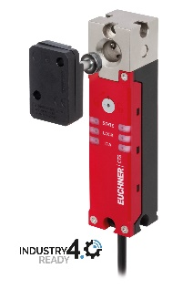
The CTS is ideal for applications requiring a high locking force in a confined space. With the new FlexFunction, the CTS combines in a single device multiple functions that are otherwise available only in separate variants.

02-Euchner-CKS2
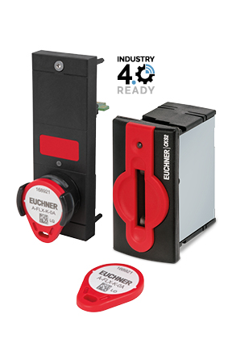
The new CKS2 key adapter meets the highest safety requirements for machine and installation lockout and starting.

Über EUCHNER GmbH + Co. KG
Die EUCHNER GmbH + Co. KG in Leinfelden ist ein international tätiges Familienunternehmen mit weltweit über 900 Mitarbeitern. 20 Tochtergesellschaften, darunter zehn in Europa, vier in Asien und vier in Nord- und Südamerika, verteilen sich mit 22 Vertriebsbüros rund um den Erdball. Geschäftsführender Gesellschafter des Unternehmens ist Stefan Euchner. Seit mehr als 60 Jahren werden bei EUCHNER Schaltgeräte entwickelt. Diese finden ihren Einsatz hauptsächlich im Maschinenbau. Eine Spitzenstellung nimmt das Unternehmen im Bereich der Sicherheitstechnik ein. EUCHNER Sicherheitsschalter überwachen elektromechanisch und elektronisch zuverlässig die Stellung von Schutztüren von Maschinen und Anlagen.
Weitere Informationen rund um das Unternehmen finden Sie im Internet unter www.euchner.de

EUCHNER GmbH + Co. KG
Kohlhammerstraße 16
70771 Leinfelden-Echterdingen
Deutschland
Tel. +49 711 7597- 0
Fax +49 711 753316
www.euchner.de
info@euchner.de

Pressekontakt
Ariane Walther
Marketing / Corporate Communications
Tel. +49 711 7597- 163
Fax +49 711 7597- 385
press@euchner.de

Social Media

