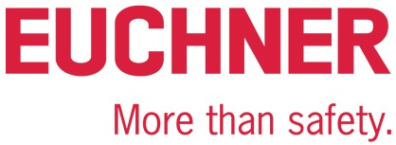

PRESS RELEASE
Leinfelden, January 2020

Euchner at the interpack 2020 trade show: Hall 3A, Stand 206

Safe access with Electronic-Key-System EKS
Euchner is showcasing its versatile product for electronic access control and management: the Electronic-Key-System EKS. This transponder-based read/write system has already proven its worth in the packaging machinery industry by preset parameters that provide protection against unauthorized access. The RFID-based EKS features the main advantage of being freely programmable and therefore highly versatile. The Electronic-Key stores the access rights for each employee. A reader scans the data and forwards this information to the control system. Additional uses for the EKS system include controlling specific functions and accessing encrypted process parameters for an installation. What’s more, one system variant is the perfect choice for hygienically sensitive areas in the food and pharmaceutical industries. Another application for the EKS system is functionally safe selection of operating mode, enabling users to select the required operating mode and activate the corresponding safety function.

Maximum safety throughout the packaging process
Euchner’s diverse safety solutions can be perfectly integrated into modular systems to protect people, machines and products in the packaging sector. The product range comprises guard locking devices and access management systems as well as products such as door detectors, door locking systems and pendant stations. For all of its products, Euchner guarantees exacting quality far exceeding the requirements in standards and laws. Customers can rely on Euchner as a partner with over 60 years of safety engineering expertise. At its headquarters in Leinfelden near Stuttgart, this family-run company develops and manufactures the right solution for any application in any batch size, large or small.
[Characters with blanks 1,918]
EUCHNER – More than safety.
Pictures: Euchner GmbH + Co. KG

01-Euchner-Abfuellanlage-EKS
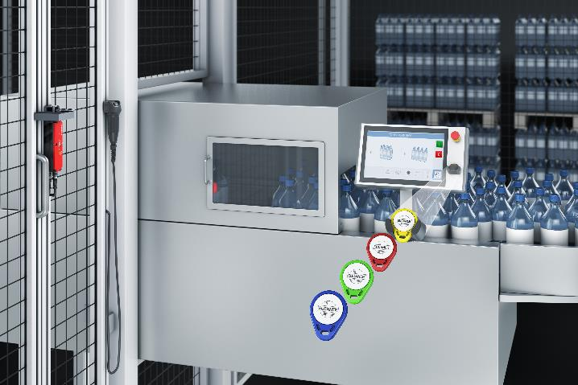
The Electronic-Key-System EKS from Euchner is suitable for access management and for functionally safe selection of operating mode.

Short profile: EUCHNER GmbH + Co. KG
EUCHNER GmbH + Co. KG in Leinfelden is an international family-owned company with more than 800 employees worldwide. 18 subsidiaries, of which ten are in Europe, four in Asia and four in North and South America, cover the globe along with 22 sales offices. The company is managed by Stefan Euchner. Switchgear has been developed at EUCHNER for more than 60 years. These devices are used primarily in the field of mechanical engineering. The company has a leading position in safety engineering. EUCHNER safety switches monitor the position of safety guards on machines and installations electromechanically and electronically with a high degree of reliability.

More information about the company is available on the Internet at www.euchner.com

EUCHNER GmbH + Co. KG
Kohlhammerstraße 16
70771 Leinfelden-Echterdingen
Deutschland
Tel. +49 711 7597- 0
Fax +49 711 753316
www.euchner.de
info@euchner.de

Press contact
Ariane Walther
Marketing / Corporate Communications
Tel. +49 711 7597- 163
Fax +49 711 7597- 385
press@euchner.de

Social Media

