PRESS INFORMATION
Leinfelden, March 2020

Euchner at the interpack 2020 trade show: Hall 3A, Stand 206

The best things come in small packages
Transponder-coded guard locking for small doors and flaps
Euchner’s new, compact CTM transponder-coded guard locking provides process and personnel protection in the smallest of spaces, making it the perfect solution for securing small doors and flaps. The real bonus is that, at only 120 x 36 x 25 mm in size, the switch is especially easy to integrate into packaging machines. Typical applications include case packers and dosing, filling and sealing machines. The innovative ball actuator supported on an elastomer bearing can even secure doors with extremely small pivoting radii. What’s more, it also guarantees the highest degree of protection IP69. The switch’s special hygienic version makes it particularly suitable for the demanding food and pharmaceutical industries. The CTM provides reliable Cat. 4/PL e safety door protection according to EN ISO 13849. Thanks to its different product variants and interfaces, the switch offers the right solution for every user and is well-suited to Industry 4.0 applications because of its IoT-compatible communication with IO-Link.
Maximum safety throughout the packaging process
Euchner’s diverse safety solutions can be perfectly integrated into modular systems to protect people, machines and products in the packaging sector. The product range comprises guard locking devices and access management systems as well as products such as door detectors, door locking systems and pendant stations. For all of its products, Euchner guarantees exacting quality far exceeding the requirements in standards and laws. Customers can rely on Euchner as a partner with over 60 years of safety engineering expertise. At its headquarters in Leinfelden near Stuttgart, this family-run company develops and manufactures the right solution for any application in any batch size, large or small.
[Characters with blanks 1,927]
EUCHNER – More than safety.

Pictures: Euchner GmbH + Co. KG

01-Euchner-CTM
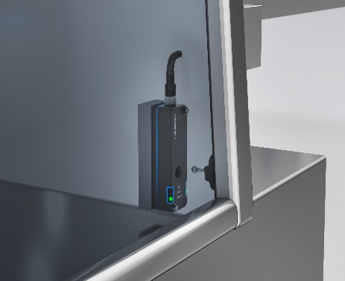
The new CTM door locking mechanism secures small doors and flaps with the highest level of safety, e.g. in case packers and dosing, filling and sealing machines.

02-Euchner-CTM
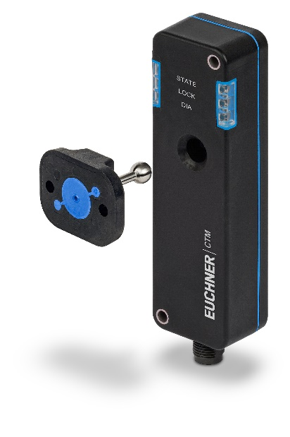
The new, compact CTM transponder-coded guard locking provides process and personal protection in the smallest of spaces.

Short profile: EUCHNER GmbH + Co. KG
EUCHNER GmbH + Co. KG in Leinfelden is an international family-owned company with more than 800 employees worldwide. 18 subsidiaries, of which ten are in Europe, four in Asia and four in North and South America, cover the globe along with 22 sales offices. The company is managed by Stefan Euchner. Switchgear has been developed at EUCHNER for more than 60 years. These devices are used primarily in the field of mechanical engineering. The company has a leading position in safety engineering. EUCHNER safety switches monitor the position of safety guards on machines and installations electromechanically and electronically with a high degree of reliability.

More information about the company is available on the Internet at www.euchner.com

EUCHNER GmbH + Co. KG
Kohlhammerstraße 16
70771 Leinfelden-Echterdingen
Germany
Tel. +49 711 7597- 0
Fax +49 711 753316
www.euchner.de
info@euchner.de

Press contact
Ariane Walther
Marketing / Corporate Communications
Tel. +49 711 7597- 163
Fax +49 711 7597- 385
press@euchner.de

Social Media

