PRESS RELEASE
Leinfelden, September 2019

Euchner at the SPS 2019 trade show: Hall 7, Stand 280

Safety solutions for all sectors and requirements

Euchner will be presenting its latest safety engineering products for the protection of people, machines and products in a diverse range of industries at this year’s SPS trade show. They include the compact safety switch with guard locking CTM, the safety door protection devices MGB2 Modular and MGB2 Classic, as well as the successful duo combining the safety switch CES-C07 for small installations and flaps with the safety module ESM-CB. Application examples from the machine tool, packaging machinery and automotive industries will give visitors a small glimpse of the numerous applications and industries that use safety solutions from Euchner.

Smart, compact, safe – the door locking mechanism CTM
Economic efficiency, machine availability and safety requirements were key considerations during the development of the latest innovation: the door locking mechanism CTM. Only 120 x 36 x 25 millimeters in size, the switch can be installed almost invisibly in machines. It therefore meets the latest market requirements, because the space available for safety engineering in machine designs is steadily decreasing. The innovative ball actuator supported on an elastomer bearing can secure even doors with extremely small pivoting radii from 150 mm. The CTM’s special hygienic version is particularly suitable for the demanding food and pharmaceutical industries. The bistable guard locking function of the safety switch CTM ensures that guard locking remains in its momentary state if the power fails or the installation is switched off. This will keep the door locked if it was already locked before. If guard locking was not previously activated, the door can be opened and closed as needed. This makes it practically impossible to lock in people unintentionally if the power should fail. The CTM’s intelligent communication capabilities future-proof it for Industry 4.0. It can simply be connected in series with other Euchner devices, for example. The integrated interface additionally permits connection to the new evaluation unit ESM-CB, which forwards the data via IO-Link to the higher-level control system.
Maximum personalization for safety door systems
Euchner once again offers exactly what the market needs with its development of the MGB2 Modular and MGB2 Classic. Both solutions for securing safety doors and fences belong to the second generation of the globally successful Multifunctional Gate Box MGB. Users will particularly appreciate the many ways the systems can be personalized with more available variants and functions, as well as diverse networking options and possibilities for Industry 4.0 applications.
The safety door protection devices feature a modular design. It is easy to implement many personalized requirements for safety door systems through any combination of the devices with numerous freely selectable submodules. Submodules can be equipped with pushbuttons, selector switches, key-operated rotary switches or emergency stop buttons.
With the Multifunctional Gate Box MGB2 Modular, the actual locking module is physically separated from the bus module with integrated PROFINET/PROFISAFE. Two submodules allow you to integrate up to six different control elements into the locking module. The extension module MCM can expand the functionality of the MGB2 Modular even more. Unlike the Modular variant, the Classic version does not communicate via a bus system but is instead linked directly to the respective control system. It is therefore the ideal solution for non-networked installations wired in parallel.

High machine availability with safety switch CES-C07 and safety module ESM-CB
The safety switch CES-C07 and the safety module ESM-CB Euchner will be showcasing at the SPS trade show are an unbeatable duo, offering a new level of freedom in designing safety solutions for smaller installations. Together, they can communicate at the Industry 4.0 level and meet requirements up to a safety function of category 4, as well as Performance Level e (PLe). This results in a wealth of advantages for machine availability: previously, when safety switches without communication were connected in series, much effort was required to locate the switch that had triggered a machine stop. The subsequent troubleshooting was often difficult and caused unnecessarily long downtimes.
The new team comprising safety switch CES-C07 and safety module ESM-CB can greatly reduce downtimes, because safety switch CES-C07 provides process-relevant parameters in real time. As such, it is possible to identify not only urgent problems, but also to obtain information for preventive maintenance. The sensors measure, for instance, relevant parameters in the surroundings to indicate in good time whether the installation is about to fail. The system even signals attempts at tampering. When safety module ESM-CB is used, this information is automatically polled from each switch in the chain and provided to the control system via IO-Link.
Selection of safe operating mode on machines with EKS
Without suitable operating modes, safety guards on many machines and installations still must be tampered with by bypassing for maintenance and servicing work. Providing selection of operating mode allows the operator to select the required operating mode and activate the suitable safety guard. The Electronic-Key-System EKS that Euchner will be exhibiting at the trade show is ideal for convenient selection of operating mode in full compliance with laws.
The EKS consists of a read station and at least one Electronic-Key. The Electronic-Key includes a writable memory, offering many options for improving selection of operating mode and making it safer. EKS Electronic-Keys can be assigned to specific persons. This transfers responsibility to the Electronic-Key holder and thereby effectively prevents Electronic-Keys from being passed along or left inserted. Unlike passwords and conventional keys, an EKS Electronic-Key cannot simply be copied. Additionally, access management through individual storage of rights provides an overview of the user group at all times. If an Electronic-Key should be lost, it can be disabled. This keeps you in control of the Electronic-Keys.
Two different EKS systems are available: the EKS with data interface and the EKS Light. The EKS with data interface features an Electronic-Key with freely programmable memory. With this EKS, applications such as access to control systems/operating parameters and entry of an expiration date can be implemented in addition to selection of operating mode. The Electronic-Key data are transmitted from the read station to the control system via the data interface (e.g. PROFINET, PROFIBUS, USB Ethernet TCP/IP). The EKS Light has five outputs, and the Electronic-Key is evaluated directly in the device. As the evaluation is integrated, the EKS Light can perform only a single function such as controlling access to selection of operating mode. The outputs are connected directly to the control system or, if necessary, also to the safety engineering.

[Characters with blanks 4,949]
EUCHNER – More than safety.

Pictures: EUCHNER GmbH + Co. KG

Download link for the pictures:
https://www.euchner.de/de-de/news/sps-messevorbericht/
01_Euchner-Sicherheitsschalter-ctm-lebensmittelindustrie.jpg
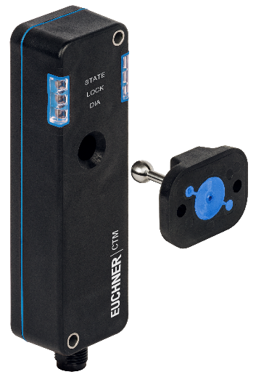
Smart, compact and safe – the special design of the new compact door locking mechanism CTM for use on small, lightweight doors and flaps makes it suitable for applications in the machine tool, packaging and food industries, for example.

02_Euchner_MGB2_Modular_Wechsel-Submodule.jpg
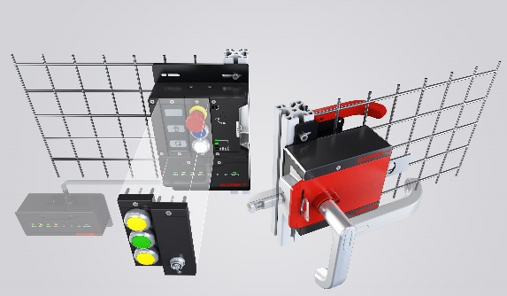
High level of personalization with the MGB2 Modular from Euchner: submodules with control elements are simply plugged into the locking module. Replacement during operation is possible, as the system is hot pluggable.
03_Euchner-CES-C07_ESM-CB_Industrie-4.0.jpg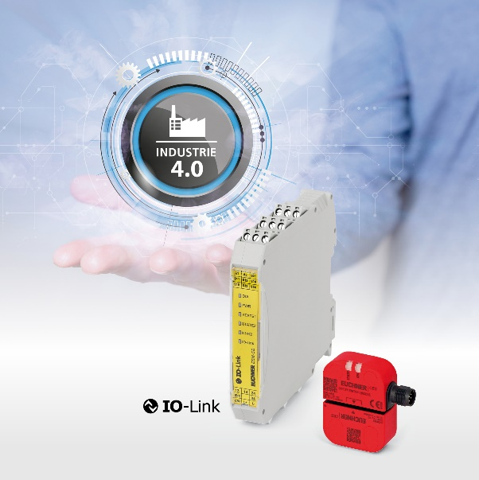
Safety switch CES-C07 and safety module ESM-CB: particularly in smaller installations, these efficient team players can significantly reduce downtimes. All the relevant sensor and device data are sent to the control system via IO-Link.

04-Euchner-EKS-Betriebsartenwahl

The Electronic-Key System EKS makes selection of operating mode even safer.

Short profile: EUCHNER GmbH + Co. KG
EUCHNER GmbH + Co. KG in Leinfelden is an international family-owned company with more than 800 employees worldwide. 18 subsidiaries, of which ten are in Europe, four in Asia and four in North and South America, cover the globe along with 22 sales offices. The company is managed by Stefan Euchner. Switchgear has been developed at EUCHNER for more than 60 years. These devices are used primarily in the field of mechanical engineering. The company has a leading position in safety engineering. EUCHNER safety switches monitor the position of safety guards on machines and installations electromechanically and electronically with a high degree of reliability.

More information about the company is available on the Internet at
www.euchner.com

EUCHNER GmbH + Co. KG
Kohlhammerstraße 16
70771 Leinfelden-Echterdingen
Germany
Tel. +49 711 7597- 0
Fax +49 711 753316
www.euchner.com
info@euchner.de
press@euchner.de

Social Media

