PRESS RELEASE
Leinfelden, April 2023

Euchner at the 2023 automatica trade show: Hall A4, Booth 302

Ready for anything the future may bring – with automation safety solutions

Innovative safety engineering protects people, machinery and processes while meeting the latest communication standards in automated production. For Euchner, this year’s automatica trade show is all about “Smart Safety” and the company’s latest innovations for communication via IO-Link, AS-i Safety at Work and common fieldbus systems. Featured trade show products include the new and compact CTS high-performance safety guard locking device and the successful MGB2 Modular safety door system, which is now compatible with EtherCAT/ FSoE and EtherCAT P/ FSoE too. What’s more, the company will show examples demonstrating all the ways users can benefit from IO-Link in industrial safety engineering. Euchner Safety Services machinery safety experts will also be on hand to present the company’s wide range of engineering services for machine manufacturers and operating organizations.

One fits all – the compact, flexible CTS safety switch
The CTS safety switch is one of the latest developments in transponder-coded safety guard locking. Measuring only 135 by 31 by 31 mm and featuring a locking force up to 3,900 N, plus diverse mounting options, this switch is versatile enough for almost any application. The CTS can be mounted in three directions to protect both hinged and sliding doors. Users can also add an escape release at any time. This transponder-coded safety switch with guard locking provides maximum safety.
The CTS FlexFunction switch also combines in a single device multiple functions otherwise available only in separate variants. With or without guard lock monitoring and with a high or low coding level for actuator code evaluation – the choice is up to the user with CTS. Functions are selected by choosing the appropriate actuator. As with most Euchner switches, the CTS also features a variety of connection options. Combining the CTS with a Euchner IO-Link Gateway gives it the additional benefit of communicating in Industry 4.0 applications.

IO-Link is the future
All Euchner Smart Safety solutions can communicate via IO-Link as standard. Reading process and device data from a safety switch is simple with an IO-Link Gateway from Euchner. Data and information are transferred to the IO-Link master in real time, and from there to the various fieldbus systems. Process data includes all status signals indicating the door or guard locking position or whether a switch is out of adjustment, for example. Additionally, acyclical services can collect environmental data such as the switch temperature, applied voltage, number of switching cycles and other values. Communicating via IO-Link enhances flexibility and efficiency in automated production. Installing or replacing devices is a snap. The data are an effective preventive maintenance tool enabling the user to increase machine availability and boost productivity.

MGB2 Modular: new networking options for EtherCAT/FSoE
The MGB2 Modular secures access points in safety doors and fences protecting the danger zones of machines and installations. This highly functional door locking system is already a great success in many sectors. Users appreciate the system’s modular design and its wide scope for customization. The diverse connection options are further proof. Alongside the PROFINET/PROFIsafe and EtherCAT P/FSoE bus protocols, an MBM bus module for connection to the safe EtherCAT/FSoE protocol is now also available.
The MGB2 Modular system comprises a locking module, integrated operator controls and indicators, plus optional expansion modules. Users can connect it through the selected MBM bus module. These smart devices provide a wealth of diagnostic data, including voltage, temperature and number of switching cycles.
The new submodule with CKS2 safe key system is a welcome addition to the MGB2 product line. This powerful combination opens up many new applications. The new CKS2 key system can be used for machine and installation lockout and starting, for assigning authorization to select an operating mode, or as a key transfer system. The system guarantees maximum safety thanks to its highly coded RFID keys. Connecting the MGB2 via bus systems lets the overall control system monitor all Electronic-Key adapters.

Machinery safety consulting, engineering and training
Euchner Safety Services will present its range of consulting and engineering services at the automatica trade show. Our experts help manufacturers and operating organizations meet legal safety requirements in all machine and installation life cycles. The experienced team can support customers as a full engineering services provider. Alongside design and planning, these services encompass the implementation and integration of safety solutions. Machine operating organizations in particular will benefit from this comprehensive service for their conversions, integration and retrofitting. The Euchner Academy offers machine manufacturers and operating organization practical training courses all about machinery safety, developed and accompanied by identified specialists.

[Characters with blanks 5,867]
EUCHNER – More than safety.

Pictures: Euchner GmbH + Co. KG

01_Euchner-CTS-IO-Link-Gateway
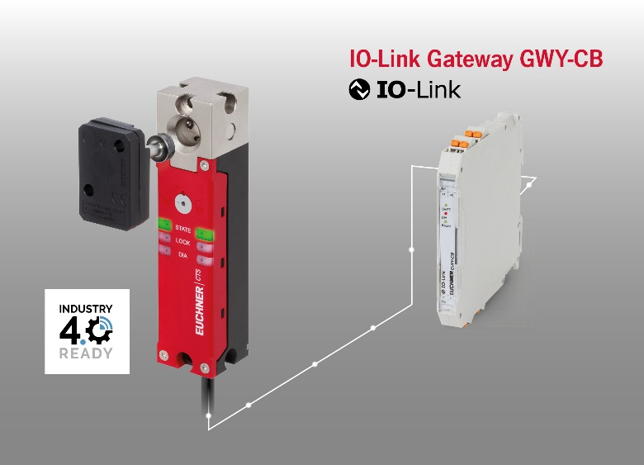
The CTS transponder-coded guard locking device is compact, features a high locking force and is IO-Link compatible in conjunction with an Euchner Gateway.

02-Euchner-MGB2-Modular-Ethercat
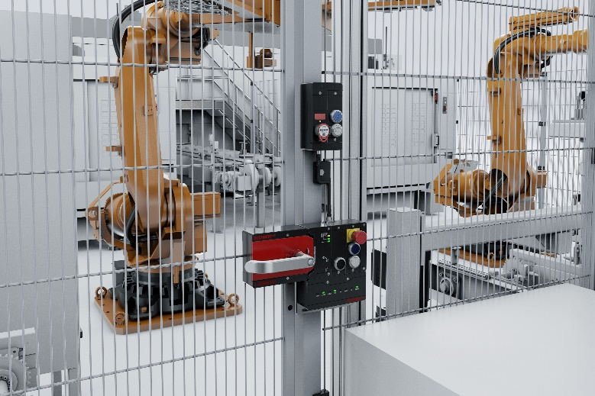
The successful MGB2 Modular door locking system is now available in a version for connection to EtherCAT/FSoE in addition to the EtherCAT P/FSoE variant.

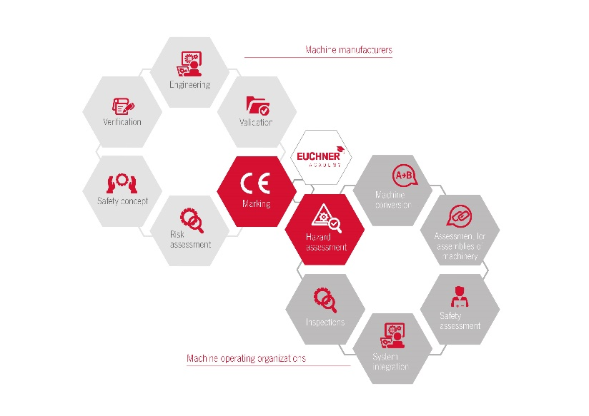
03-Euchner-Safety-Services-Waben
Euchner Safety Services helps manufacturers and operating organizations meet legal safety requirements in all machine and installation life cycles.

The pictures are available for download here:
https://my.hidrive.com/share/filr-g6c9l
Short profile: EUCHNER GmbH + Co. KG
EUCHNER GmbH + Co. KG in Leinfelden is an international family-owned company with more than 900 employees worldwide. 20 subsidiaries cover the globe along with 22 sales offices. The company is managed by Stefan Euchner. Switchgear has been developed at EUCHNER for 70 years. These devices are used primarily in the field of mechanical engineering. The company has a leading position in safety engineering. EUCHNER safety switches monitor the position of safety guards on machines and installations electromechanically and electronically with a high degree of reliability.

More information about the company is available on the Internet at www.euchner.com

EUCHNER GmbH + Co. KG
Kohlhammerstraße 16
70771 Leinfelden-Echterdingen
Germany
Tel. +49 711 7597- 0
Fax +49 711 753316
www.euchner.com
info@euchner.de

Press contact
Ariane Walther
Marketing / Corporate Communications
Tel. +49 711 7597- 163
Fax +49 711 7597- 385
press@euchner.de

Social Media

