# K:\Unternehmen\CI & CD\Logos\EUCHNER\eps\Wortmarke u. Claim\EUCHNER -More than safety.jpg

# PRESS RELEASE

Leinfelden, November 2019

**Euchner’s MGB2 *Classic* and MGB2 *Modular***

**Multifunctional safety door systems for every requirement**

**The very successful MGB Multifunctional Gate Box has evolved: the latest generation of the intelligent safety door system now allows users to design protection for guards that meets their individual requirements. The MGB2 *Modular* and the MGB2 *Classic* offer more variations, additional functions, different networking options and intelligent communication features for IoT applications. The MGB2 *Modular* for PROFINET has enjoyed high demand on the market ever since it was launched a year ago. The conventionally wired MGB2 *Classic* has been available since summer 2019 and its many advantages make it just as popular with an ever-increasing number of users.**

The MGB system protects safety doors and fences in machines and installations from dangerous machine movements and combines a safety switch, bolt and door locking mechanism into one. The MGB already has an established reputation in many different sectors, including the automotive industry and other fields where automation is used. The latest generation of the MGB2 provides users with a highly functional door locking system with guard locking that not only meets the highest safety levels up to PL e but also has the flexibility to adapt to future requirements. This makes it a very smart investment.

**Maximum personalization for safety door systems**

No two safety applications are the same. Some production processes need an integrated emergency stop to secure safety doors with guard locking, while others need additional request and acknowledgment buttons to be fitted directly onto the safety door. It’s also possible that, over time, new requirements may arise for safety door systems as a result of conversions or expansions to machines, installations and production lines. A solution that can be adjusted to meet all of these requirements is a sensible choice. The new versions of the Multifunctional Gate Box, MGB2 *Modular* and MGB2 *Classic*, have a modular system design that makes them ideal for customers’ individual needs.

**The MGB2 *Modular*: individual submodules for increased versatility**

The MGB2 *Modular* comprises a locking module incorporating submodules with control and display functions and a bus module for connecting to PROFINET/PROFIsafe. The guard locking submodules can be equipped with control elements such as pushbuttons, selector switches, key-operated rotary switches or emergency stop buttons as needed. The combination options are infinite. Two additional submodules allow you to integrate up to six different control elements in the locking module. The control elements can be replaced at any time during operation because the MGB2 *Modular* is hot pluggable. The MCM extension module can expand the MGB2 *Modular’*s functions even further by adding up to four more submodules.

The actual locking module can be physically separated from the compact MBM bus module, which has the considerable advantage that only one bus module is required to connect up to six MGB2 *Modular* locking modules. This means that unlike its predecessor, which needed two or three bus nodes for collecting the signals from two or three safety doors, the MGB2 *Modular* only needs one bus node. Besides needing fewer devices, the user also requires fewer network cables and network addresses, and ultimately also saves on storage capacity in the control system, which is becoming all the more expensive, not least in view of the smart factory of tomorrow. If space is limited, the bus module can simply be installed remotely in another suitable location.

**The MGB2 *Classic*: the solution for parallel-wired installations**

The MGB2 *Classic* version has a modular design just like the MGB2 *Modular* and the locking module submodules can also be fitted with individual control elements. Unlike the *Modular* variant, the MGB2 *Classic* version does not communicate via a bus system but is instead linked directly to the relevant control system. It is therefore the ideal solution for non-networked parallel-wired installations. The system features two OSSD outputs, provides continuous diagnostic information via an LED indicator, and can be connected in series with up to ten devices.

The MGB2 versions can already read a great variety of data, from temperature right through to the current applied voltage, which means the system is more than ready for Industry 4.0 applications.

[4,723 characters incl. spaces]

**Features of Euchner’s new MGB2 generations**

* Guard locking with guard lock monitoring
* Locking force 2,000 N
* 1,000 joules shock resistance (impact energy) in accordance with EN ISO 14120
* Robust industrial housing
* Degree of protection IP65
* Category 4/PL e for all safety functions according to EN ISO 13849-1
* Can be used on hinged and sliding doors
* Infinite combination options for the control elements in a submodule
* Optimized for easy installation on profiles
* Hot-plugging function simplifies servicing
* Can be adjusted to doors hinged on the left or right
* Integrated floor plate for easy installation
* Comprehensive diagnostic functions
* Optional escape release

**Special features of the MGB2 Multifunctional Gate Box *Modular***

* Modular design with submodules
* Up to twelve control elements possible with the MCM extension module
* Up to six MGB2 *Modulars* or MCMs can be connected to one MBM bus module
* PROFINET/PROFIsafe
* Web server available for diagnosis

**Special features of the MGB2 Multifunctional Gate Box *Classic***

* Maximum flexibility due to modular design
* Simple connection thanks to two plug-in coded terminals or RC18 plug connectors
* Safe OSSD outputs
* Up to 10 devices can be connected in series

**01-Euchner-Schutztuersystem-MGB2-Modular.jpg**

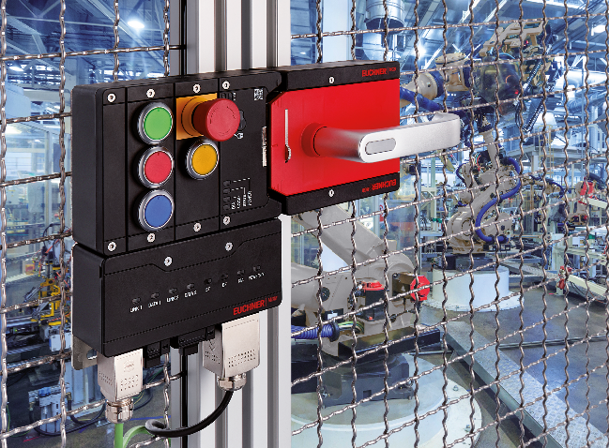

Euchner’s MGB2 generation is a modular and highly flexible system fit for the future; submodules can be equipped with customized functions. Modifications or supplementing additional functions are possible at any time.

**02-Euchner-MGB2-Modular-abgesetze-Montage.jpg**

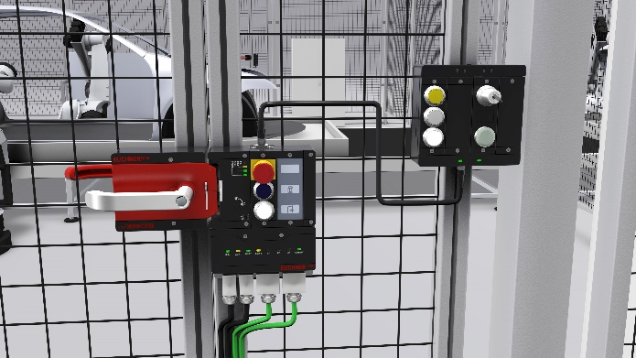

Remote installation also possible for bus module and extension module.

**Short profile: EUCHNER GmbH + Co. KG**

*EUCHNER GmbH + Co. KG in Leinfelden is an international family-owned company with more than 800 employees worldwide. 18 subsidiaries, of which ten are in Europe, four in Asia and four in North and South America, cover the globe along with 22 sales offices. The company is managed by Stefan Euchner. Switchgear has been developed at EUCHNER for more than 60 years. These devices are used primarily in the field of mechanical engineering. The company has a leading position in safety engineering. EUCHNER safety switches monitor the position of safety guards on machines and installations electromechanically and electronically with a high degree of reliability.*

More information about the company is available on the Internet at **www.euchner.com**

EUCHNER GmbH + Co. KG

Kohlhammerstraße 16

70771 Leinfelden-Echterdingen

Deutschland

Tel. +49 711 7597- 0

Fax +49 711 753316

www.euchner.de

info@euchner.de

**Press contact**

Ariane Walther

Marketing / Corporate Communications

Tel. +49 711 7597- 163

Fax +49 711 7597- 385

press@euchner.de

**[](https://www.xing.com/companies/euchnergmbh+co.kg)[](https://www.youtube.com/user/marketingeuchner)[](https://www.instagram.com/euchnergermany/)[](https://de.linkedin.com/company/euchner-gmbh-co-kg)[](https://www.facebook.com/euchnergmbh/)Social Media**