PRESS RELEASE
Leinfelden, May 2022

Euchner: premiere at the 2022 Hannover Messe trade show

One fits all – the new FlexFunction CTS safety switch

Maximizing flexibility was the main development goal for the new Euchner CTS guard locking device. The result is a compact safety switch that produces a high locking force, is suitable for universal use in diverse installation orientations and can be mounted in various ways thanks to its expanded IO-Link communication capabilities and well-thought-out design. The CTS switch’s key innovation is the new FlexFunction feature, which allows a single device to perform a wide variety of functions that would otherwise require several switch variants. FlexFunction paves the way for new approaches to planning and operation.

Small size, high locking force, flexible installation
Measuring only 135 x 31 x 31 millimeters in size and delivering a maximum locking force of 3,900 N, the CTS is an attractive solution for many applications. For hinged or sliding doors or extremely small door radii – three different switch mounting directions and a universal actuator with floating bearing enable the CTS to be used almost anywhere. An extendable escape release with actuating mechanism can also be added at any time. The switch offers maximum safety despite its compactness. Based on proven transponder technology, the CTS achieves category 4/PL e according to EN ISO 13849-1 and meets all the requirements of EN ISO 14119.

Versatile FlexFunction: diverse applications with a single device
The key innovation is not immediately apparent, because it is not the switch itself but the transponder-coded actuator that determines the switch’s function. In other words, the switch’s function is defined by selecting the appropriate actuator. Euchner uses the name “FlexFunction” for this new, patented design. The customer selects the suitable actuator to activate exactly the CTS device function required. The benefits speak for themselves: the user can change from guard locking for process protection to guard locking for personnel protection and select a high or low coding level as needed while keeping the same basic unit. The switch is configured and assigned its function when the actuator is taught-in for the first time. If the requirements change or the switch is relocated later on, all that needs to be done is to reconfigure the switch for its new function using a new actuator. Thanks to FlexFunction, the CTS safety switch is future-proof regarding any required retrofitting or conversion work and provides the additional benefits of smaller spare part inventories and more streamlined procurement processes.

Easy to integrate into applications and systems
Applications for the CTS include everything from separate operation and series connection to linking to a higher control system level. The right connecting cable for any use can be selected from the range of versions with plug connectors or flying leads. Combining the CTS with an Euchner IO-Link Gateway additionally provides communication capabilities for Industry 4.0 applications enabling comprehensive diagnostics.

[Characters with blanks 3,256]

EUCHNER – More than safety.

Pictures: Euchner GmbH + Co. KG

01-Euchner-CTS

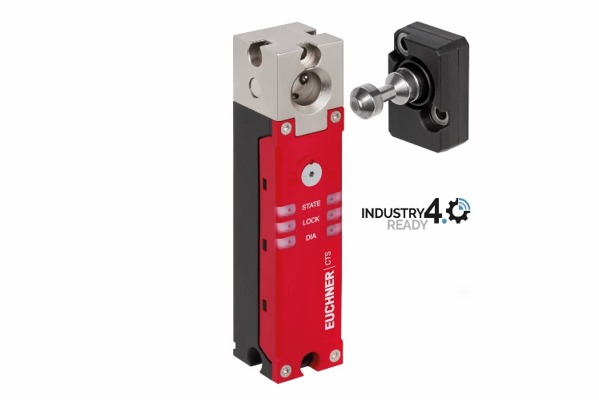
Besides featuring the proven benefits of Euchner’s transponder-coded safety switches with guard locking, the new FlexFunction CTS combines in a single device multiple functions that are otherwise available only in separate variants.

Short profile: EUCHNER GmbH + Co. KG
EUCHNER GmbH + Co. KG in Leinfelden is an international family-owned company with more than 900 employees worldwide. 20 subsidiaries, of which ten are in Europe, four in Asia and four in North and South America, cover the globe along with 22 sales offices. The company is managed by Stefan Euchner. Switchgear has been developed at EUCHNER for more than 60 years. These devices are used primarily in the field of mechanical engineering. The company has a leading position in safety engineering. EUCHNER safety switches monitor the position of safety guards on machines and installations electromechanically and electronically with a high degree of reliability.

More information about the company is available on the Internet at www.euchner.com

EUCHNER GmbH + Co. KG
Kohlhammerstraße 16
70771 Leinfelden-Echterdingen
Germany
Tel. +49 711 7597- 0
Fax +49 711 753316
www.euchner.com
info@euchner.de

Press contact
Ariane Walther
Marketing / Corporate Communications
Tel. +49 711 7597- 163
Fax +49 711 7597- 385
press@euchner.de

Social Media

