PRESS RELEASE
CTM presentation for packaging industry applications
Leinfelden, September 2019

Among the Smallest in its Class
Transponder-Coded Guard Locking Device for the Packaging Industry

Euchner is targeting packaging machine manufacturers with its transponder-coded door locking mechanism CTM. Ensuring absolute reliability while providing maximum safety, the new, highly compact CTM can be perfectly integrated into the design of any packaging machine. Its smart communication capabilities additionally ensure compliance with today’s and tomorrow’s Industry 4.0 requirements.

Digitalization and automation are proliferating in many industries, and the packaging industry is no exception. Moreover, packaging lines for drugs, health care, cosmetics, foods, drinks and other products run at high speeds and operate with short cycle times. The use of fast robots can often lead to very high throughput rates. These highly automated processes must meet very stringent safety demands, irrespective of whether these processes involve primary, secondary or final packaging. The underlying, generally applicable EU Machinery Directive 2006/42/EC and the EN 415-10 standard prescribe detailed protective measures for various types of packaging machines and their peripheral equipment, including the upstream and downstream conveyors, gripper systems and palletizers. Equipment requiring protection can include doors, flaps, safety fences and other safety devices. For example, hazards arising due to moving parts, rotating components and high temperatures must be ruled out by additional design measures.

Interplay between economy, availability and safety

It goes without saying that safety systems such as light grids, sensors and guard locking devices in machines and installations must be highly reliable, as it is not uncommon for machines to run all day, every day. On the other hand, the protective measures must be designed to avoid interrupting production sequences while also maintaining a high level of system availability. In other words, economic concerns must be balanced against machine availability and safety requirements. Euchner put these aspects first and foremost when designing its latest innovation.

Compact size tailored to packaging equipment

Euchner developed the CTM series specifically to meet the particular requirements in the packaging sector. CTM product manager Anne Fieg stresses that close collaboration with customers from this sector was crucial when it came to developing this innovation. “We worked closely with end users to gain a clear understanding of their current market needs,” says Fieg. In her opinion the packaging sector tends to prefer more compact switches and safety systems, which can be installed so as to be nearly invisible, while using more and smaller doors with much lower locking forces than encountered in machine tool manufacturing, for example. Typical applications include case packers as well as dosing, filling and sealing machines. The CTM’s design predestines it for use in this sector. Measuring only 120 x 36 x 25 mm in size, the new Euchner system is particularly easy to fit into the housings of filling and packaging machines. Another advantage in view of the frequently limited space in packaging machines is the innovative ball actuator supported on an elastomer bearing: it can secure doors with pivoting radii as small as 150 mm.

Smallest transponder-coded guard locking device offers maximum protection

Although the CTM is one of the smallest transponder-coded switches with guard locking, compactness doesn’t mean less safety. Despite its small size, the CTM provides reliable Cat. 4/PL e safety door protection according to EN ISO 13849. In other words, the CTM achieves the highest safety level for machines and people. The new product’s bistable guard locking function always ensures maximum protection if the power should fail or when the installation is switched off, because the system will remain in its current state. If guard locking of the switch was previously actuated, the door will remain reliably locked. If guard locking was deactivated, the door can be opened and closed again as before. It is virtually impossible to trap people unintentionally. Approved for the protection of persons, the flush guard locking device with transponder coding supplements the magnetic guard locking used in packaging technology as standard. The tiny CTM system features a high coding level, and its 1,000 N of locking force is more than sufficient for most packaging industry applications. If customers require a higher locking force, such as for upstream and downstream conveyors, they are free to choose other switch types from Euchner’s wide range of products.

Special hygienic version for packaging food and drugs

The red-and-black CTM guard locking base model is designed according to hygienic aspects for easy cleaning. Its housing meets safety class IP69, meaning it can easily withstand high-pressure and steam-jet cleaners. Euchner supplements the basic version with a special variant incorporating exclusively food-safe materials. For example, the plastics used in this blue-and-black version comply with EU Regulation (EC) No. 10/2011. With its smooth surfaces, rounded edges and materials resistant to cleaning agents, the hygienic version is ideally suited for use in the first packaging of foods, medical instruments or drugs. This special version is also the perfect choice for bottling liquid care and wellness products or beverages.

High energy efficiency minimizes power consumption

Energy efficiency is playing an increasing role in packaging technology, just as in all other areas of mechanical and systems engineering. The many safety switches and guard locking devices required in a packaging line consume a relatively significant amount of power, which is why designers of such systems are increasingly paying attention to limiting the power required by the integrated systems. Connecting several guard locking devices in series via Y-distributors requires minimizing their power consumption in any case. Designed for economy, the switches from the CTM series draw only 500 milliamperes for 70 milliseconds when the solenoid polarity is reversed – not least thanks to the bistable guard locking principle. The current draw during continuous operation is only 50 to 70 milliamperes.

Ready for Industry 4.0 thanks to smart communication functions

Up to ten CTM guard locking devices can be electronically rowed up in the field. Moreover, the design engineer can easily connect them to other Euchner devices. For example, the hot-pluggable systems can be coupled with the new safety module ESM-CB to supply a steady stream of process data from the system to the higher-level control systems via the IO-Link Master. The safety module acts as a safety relay while maintaining a dialog with the connected devices. For each switch, it polls information such as the system state, the ambient conditions and other details in real time. Networking the guard locking devices in this way provides a wealth of diagnostic and analysis options for the packaging system operator. The smart communication functions offered by the integrated network are also ideal for use in Industry 4.0 applications, such as for predictive maintenance. “The desire for predictive maintenance is becoming ever more relevant in the packaging sector. Packaging machine and peripheral equipment designers are on the safe side in this respect with the CTM series from Euchner,” emphasizes Fieg.

7,440 characters

Euchner – More than safety.

Images: EUCHNER GmbH + Co. KG
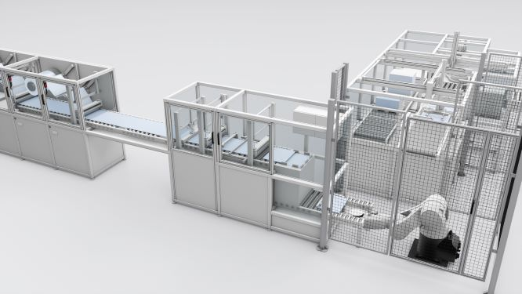

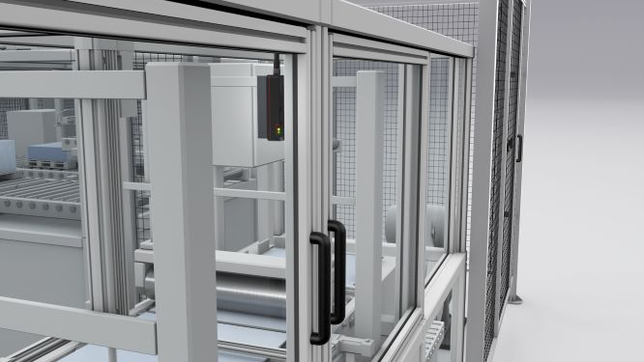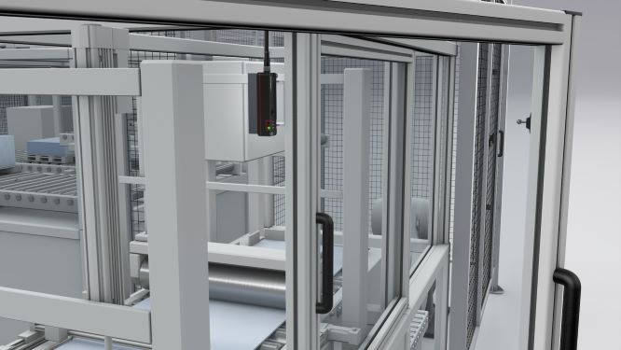
The CTM series’ bistable guard locking function prevents people from locking themselves in if the power should fail.

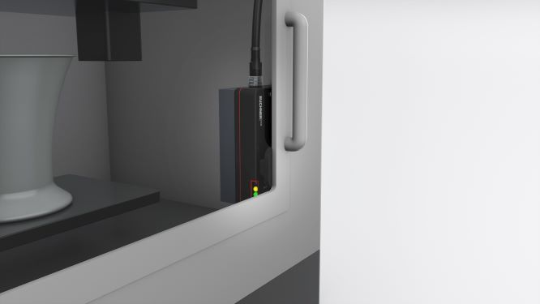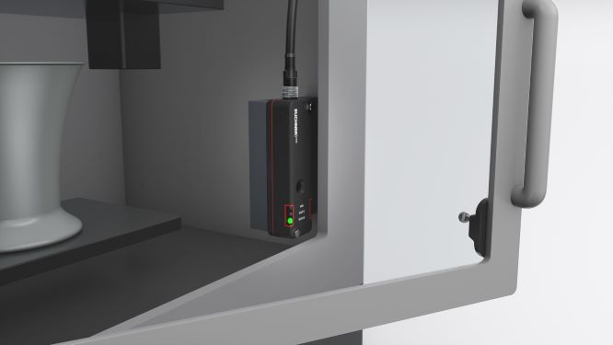
Open and shut: an innovative ball actuator on the CTM series is an ideal solution for even the smallest door radii in machines where space is at a premium.

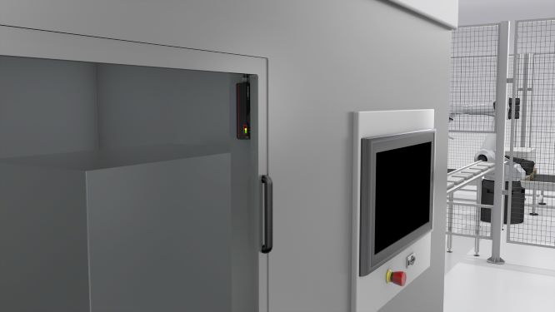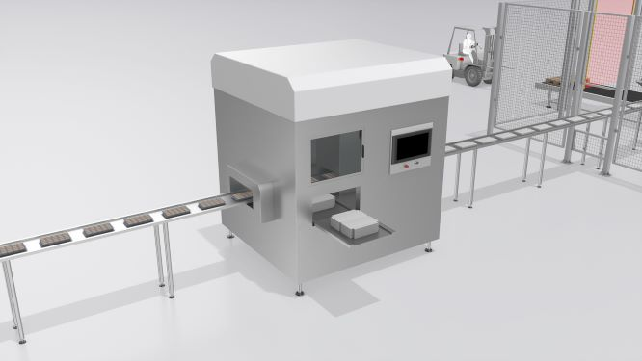
Straightforward wiring with M12 plug connectors links as many as ten CTM guard locking devices in series with each other and with other Euchner systems.

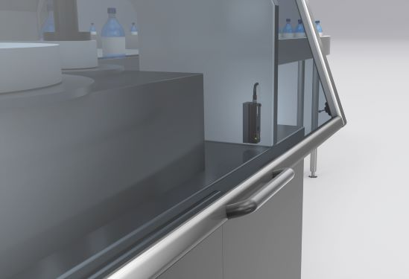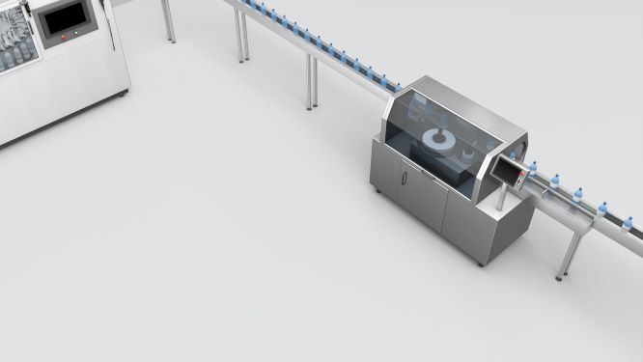
Industry 4.0 ready. The CTM series provides detailed diagnostic data to higher level control systems when combined with the new safety module ESM-CB, which will soon make predictive maintenance a reality.

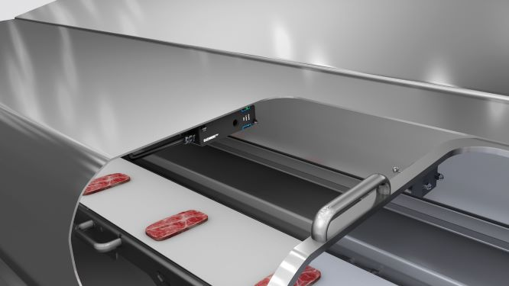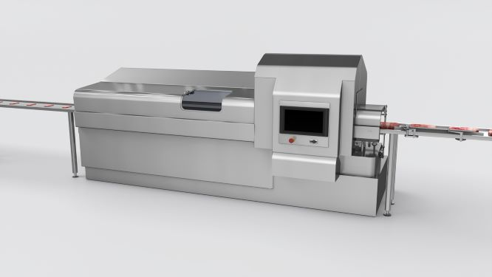
A CTM version specially designed to fulfill all hygiene standards in the food industry can be used in machines for packaging anything from meats to chocolate, for example.

Short profile: EUCHNER GmbH + Co. KG
EUCHNER GmbH + Co. KG in Leinfelden is an international family-owned company with more than 900 employees worldwide. 20 subsidiaries, of which twelve are in Europe, four in Asia and four in North and South America, cover the globe along with 22 sales offices. The company is managed by Stefan Euchner. Switchgear has been developed at EUCHNER for more than 60 years. These devices are used primarily in the field of mechanical engineering. The company has a leading position in safety engineering. EUCHNER safety switches monitor the position of safety guards on machines and installations electromechanically and electronically with a high degree of reliability.

More information about the company is available on the Internet at
www.euchner.com

EUCHNER GmbH + Co. KG
Kohlhammerstraße 16
70771 Leinfelden-Echterdingen
Germany
Tel. +49 711 7597- 0
Fax +49 711 753316
www.euchner.com
info@euchner.de
press@euchner.de

Social Media

